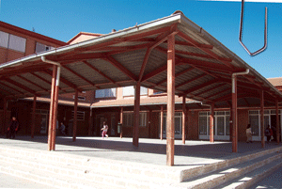 A PICTURE OF OUR SCHOOL
How are you?

Miguel Hernández is a school in San Fernando de Henares, Madrid, in Spain.

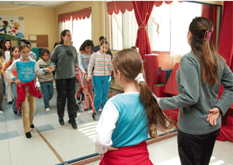

Today, is a 25th Birthday of the school.

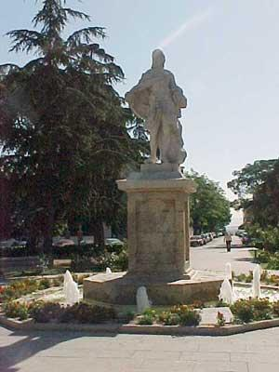
This is a statue for Fernando VI, patron of San Fernando de Henares.

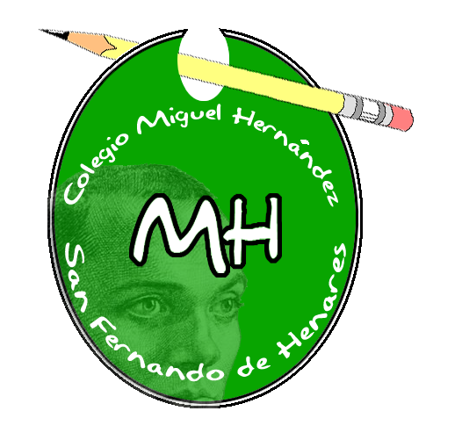
This is the shield of the Miguel Hernandez school. (It`s by Sergio)
It’s one month old

He won the prize participating in the contest titled “design your school shield”

This is document it’s by Sergio, 6ºA

