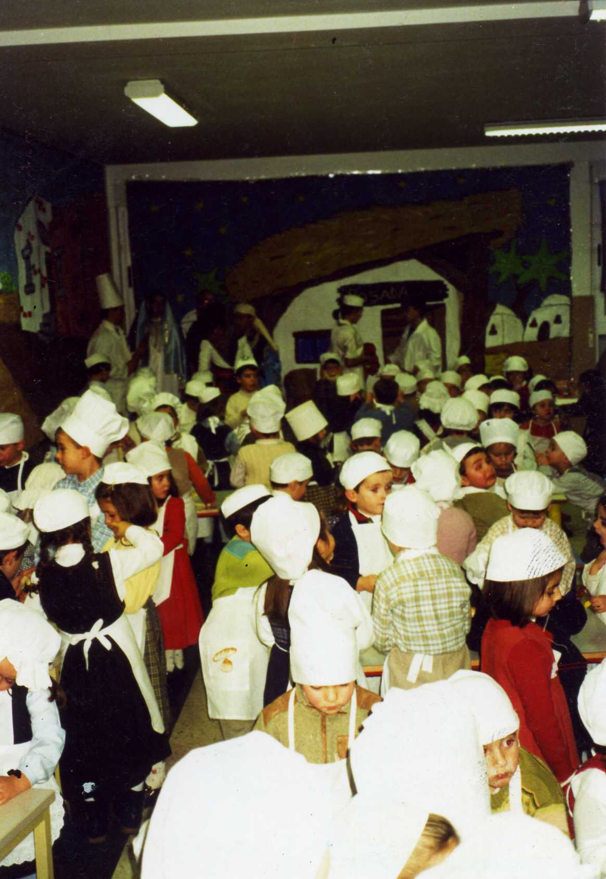

TIPICAL SPANISH CHRISTMAS DESSERT: POLVORONES

Ingredients
- 1/2 lb butter
- 1 cup granulated sugar
- 1/2 cup confectioners' sugar
- 2 eggs
- 4 cups all-purpose flour, sifted
- 1 teaspoon baking powder
- 1/2 teaspoon salt
- 1/2 cup sugar
- 2 tablespoons cinnamon

Directions
Preheat oven to 375°F
Cream butter with the 2 kinds of sugar until very creamy and light. Add eggs, one at a time, beating well after each addition. Add baking powder and salt to flour and add to cream mixture in thirds.
Roll out on floured board to about 1/4 inch thickness. Cut with cookie cutter (smallest available). Place on greased cookie sheet and bake for approximately 12 minutes, until light gold in color. Sprinkle with mixture of sugar and cinnamon while still hot. Yields: about 5 dozen.

