Croatian Cookies

Badnji Kruh (Christmas Eve Bread)
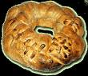
Christmas Eve bread is enjoyed in all regions of Croatia. It symbolizes the
spirit of sharing between family and friends because in many families it is
customary that everyone enjoys some while sitting around the table
together.
1 Tbsp. honey
1/2 cup warm water
1 pkg. yeast
1 1/4 cups whole wheat flour
2 cups white flour
1 1/4 cups white wine
1/2 cup whole hazelnuts
1/2 cup whole blanched almonds
1/2 cup raisins
1 3/4 cups chopped dried figs
2 Tbsp. honey, to glaze
Stir 2 Tbsp. honey into the warm water. Add yeast and mix well. Allow to
rise until foamy, approximately 20 minutes. Work a firm dough from flour,
yeast, and wine. Kneed until smooth. Add hazelnuts, almonds, raisins, and
figs. Allow to rise in a warm, draft free place for one hour until doubled
in bulk. Punch down and place in greased and floured 11 x 16 inch bread
pan. Allow to rise again for another half hour.
Bake in preheated oven at 375F until golden brown. Spread honey over warm
bread as a glaze and serve warm. The bread can be refrigerated overnight to
bake for Christmas Eve breakfast. In this case, let it warm to room
temperature after removing from the refrigerator, then allow it to rise a
second time. In the morning, you will have a fresh, warm bread.

Makovnjaca (Poppy Seed Roll)

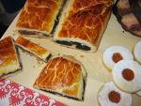

Poppy seed roll is a common Croatian desert, which is served at festive
gatherings year-round. The roll freezes well and is often kept for
unexpected visitors. Perfect served with coffee or tea.
Yeast:
1/2 cup sugar
1 Tbsp. flour
1 1/2 cups warm milk
1 pkg. yeast
Pastry:
1 3/4 cups pastry flour
1 egg
2 egg yolks
1 cup milk
pinch of salt
1 Tbsp. smetana (plum brandy)
2 Tbsp. oil
1/2 cup rum
zest of 1 lemon
1 tsp. sugar
pinch of salt
Filling:
1 1/2 cups poppy seeds
1 cup milk
3/4 cup sugar
5 tsp. raisins
2 Tbsp. Rum
zest of 1/2 lemon
cinnamon
1 egg (for glazing)

Preparing the yeast: Put the sugar, 1 Tbsp. flour, and milk (110-115F) in
medium bowl; sprinkle over yeast. Cover the bowl and allow the yeast to
prove.
Advance preparation for the filling: Finely grind poppy seeds and scald
them with boiling milk. Clean and wash raisins and soak in rum.
For the pastry: Sift flour and set aside. In a separate bowl, whisk egg,
egg yolks, and milk together. Pour sifted flour into a warmed bowl, make a
depression in center and add pinch of salt, the egg/milk mixture, smetana,
oil, rum, and lemon zest, working it all together with fingers. Finally,
add yeast mixture, mix well, and continue to beat with wooden spoon until
dough no longer sticks to spoon or bowl. Remove dough and knead slightly,
sprinkle bowl with flour, and replace dough. Cover with clean cloth and
leave to rise until double.
Preparing the Filling: Combine the cooled poppy seed/milk mixture with
other filling ingredients.
Making the rolls: Tip the doubled dough onto pastry cloth and divide in
half. Roll each half into a rectangular shape and spread the filling across
tow thirds the width of the dough. Roll it up like a Swiss roll. Place
rolls on a buttered or parchment lined cookie sheet, cover, and allow to
rise once more. When doubled, brush with a beaten egg. Bake for 40-50
minutes in oven preheated to 200F.

Paradizet

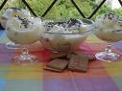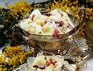

4 Egg yolks
4 Egg whites
5 ts Sugar
1/2 qt Milk
5 lg Cookies (about)

Beat egg yolks with 4 tablespoons sugar. Beat the egg whites. Boil the
milk with 1 tablespoon sugar. When the milk is boiling, add the beaten
egg to the boiling milk, spoon by spoon, letting it boil for a couple of
minutes and removing it, spoon by spoon and drop into a bowl in which you
previously place five crunched cookies. Continue this until there are no
more egg whites left. Then pour the remaining milk over the beaten egg
yolks, stirring over a hot plate until it stiffens (like pudding). When it
is thick, pourit over the egg whites and cookies. Cool in refrigerator
and serve cold.

Kotonjata (Christmas Candy)



13 lg Quince
2 Lemons
2 c Water
Sugar
1 c Lemon juice; strained

Select desired number of even colored (not spotted) quince. I use 13
large quince. Wash and peel as you would an apple. Use a shredder and
grate on largest holes. Place all meat in a heavy pot with juice of 2
lemons and 2 cups of water. Cook over lowest flame for at least an hour
or an hour and a half. Test to see if quince is soft. Remove from fire.
Measure the cooked quince by cup and return to pot. Add equal number of
quince and sugar in the same pot. Stir well until blended. Cook on
medium heat, watching carefully that it doesn't scorch. Reduce heat to
lowest setting for an hour, stirring frequently. After first half hour
add 1 cup strained lemon juice. Test quince by placing a teaspoonful on a
small plate. If it doesn't run, it's ready to pour on platters or in
Pyrex bakiing dish about 1/4 inch thick. Let dry for 3 days, turning
frequently. Cut in smaller pieces to help turn easier. When hardened,
wrap and refrigerate until used.

Creme caramel

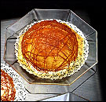

Creme caramel is a universally popular dessert, and no less so in the region of Dubrovnik, where it is known as rozata, as well as in other parts of the littoral and in Istria.

Zagorski Štrukli
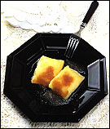

Zagorski Štrukli
(or "Štrukli a la Zagorje") is a well-known dish from the Zagorje and Prigorje regions around the city of Zagreb. The rich filling has for a long time made štrukli a much-appreciated speciality despite the fact that the ingredients could be found in even the most impoverished rural homestead. Indeed, it is the readily available character of necessary ingredients that resulted in several variants of this dish, adapted to the customs of individual areas.

Nut roll
is an Eastern European pastry of yeast bread with one or more fillings.
It is traditionally made to share at weddings, for Easter and Christmas, and on other celebrations or holidays.

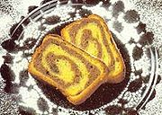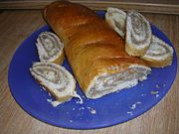

A sweet yeast dough is rolled flat, and a filling is smeared onto it. The dough-filling combination is rolled onto itself, forming a log or loaf-shape, then baked. When sliced, the cross-section shows a swirl of filling.

Zadarske Kocke - Zadar Slices
Ingredients  - 150 gr. flour  - 4 egg yolks  - 5 egg whites  - 200 gr sugar  - 100gr minced almonds  - ½ cup cold black coffee  - 1 teaspoon baking powder  For filling:  - 200 gr butter  - 4 soupspoons flour  - 300 ml milk  - 1 teaspoon vanilla sugar  - 150gr sugar  - 1 egg yolk  For glaze:  - 60 gr butter  - 100 gr cooking chocolate | 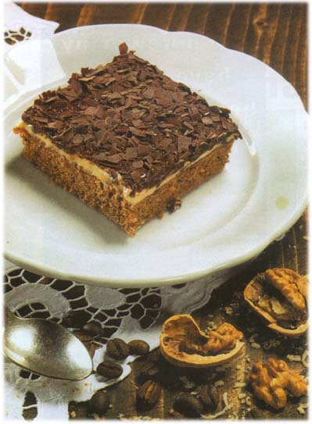
Method
- Mix egg yolks and sugar well, add almonds and coffee, mix well. Mix flour with baking powder, make stiff snow from egg whites and slowly add to egg mixture.
- Pour the mixture on greased baking tray and bake for 30 minutes at 175-200 C.
- In the mean time, make the filling. Boil milk with flour, remove from stove and let it cool off. Mix sugar, egg yolk, vanilla sugar and soft butter until it starts to foam. Now, add milk and flour and mix well.

