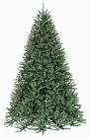

HAPPY NEW YEARS

GOOD BYE 2008

AND

WELL COME 2009

Ahmetcan Aygün
102-7/B

