New Year’s Celebrations and Resolutions

We have parties in England where we stay up to “see the new year in”. At midnight the famous bell Big Ben (in the clock tower of the Houses of Parliament in London) rings twelve times.

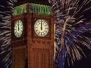
People then let off fireworks, drink a toast to the new year and link hands to sing a traditional Scottish song:
“For Auld Lang’s Syne” (For Old Time’s Sake).

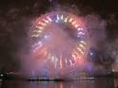

This year there were organised firework parties all over the world, but we remember that time is marked from a line that passes through London (Greenwich = GMT (Greenwich Mean Time) and enjoy our English displays. People gather together in great numbers for street and city centre parties, particularly in London and Edinburgh (Scotland).
In Scotland the celebrations of Hogmanay (New Year) are probably more popular than those for Christmas.

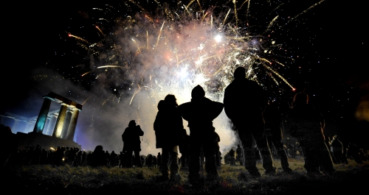

There is a whole host of “first footing” traditions which vary from region to region. My family practices a Scots one where the first person to come into the house in the New Year should have dark hair and be carrying coal. This is very strange as our house is heated by gas central heating!

There is a long tradition in England of making resolutions (promises) as the old year turns into a brand new year.

The resolution can be about anything at all, but the best ones are those that are meant to make a difference to the person who is making the resolution.

They are often about health (promising to lose weight, to get fit, to give up smoking for example), or about breaking a bad habit (biting fingernails).

Some are about work (work harder, learn my multiplication tables, read more, get my homework finished on time).

Here is one of the wisest I could find:
“I will seek elegance rather than luxury, refinement rather than fashion. I will seek to be worthy more than respectable, wealthy and not rich. I will study hard, think quietly, talk gently, act frankly. I will listen to stars and birds, babes and sages, with an open heart. I will bear all things cheerfully, do all things bravely await occasions and hurry never. In a word I will let the spiritual, unbidden and unconscious grow up through the common.” - William Ellery Channing

We talk about the New Year being the “turning over of a new leaf” as it seems a good chance to start on a new project or to make a new promise.

The challenge then of course is to keep the promise!!

Did you make any “New Year’s resolutions”?
Will you share them with us?

