


NewS Beginnings

Message from the Editor

Wishing you a belated Happy New Year!!!! This editorial has reports of some events in and around my neighbourhood. Hope you find this interesting and enjoyable too. Please send your feedback on this newsletter to shalu88@gmail.com.

Warm Regards,
Vasudha Mishra
Take a Peep…

Topic | Pg no
Christmas Celebrations | 01
Entertainment | 02
Marghazi Festivity | 03
Predictions for 2009 | 04
Welcome 2009!!! | 05
Here and There | 06
Enjoy & Relax!!! | 07

CELEBRATING THE MOOD OF CHRISTMAS:

Christmas Celebrations at the Local Churches

Children’s Day Out:

Udhayam Kalyana Mandapam, Ashok Nagar, wore a totally different look on 25th December. Over 800 children from 19 orphanages in and around Chennai participated in this Christmas Celebration organized by Nesam Trust. Special programmes like magic show, karaoke, puppet show, music show and dance performances were conducted for the children. Director Mariaapan, singer Parassana and others participated in the programme and distributed gifts to the children.

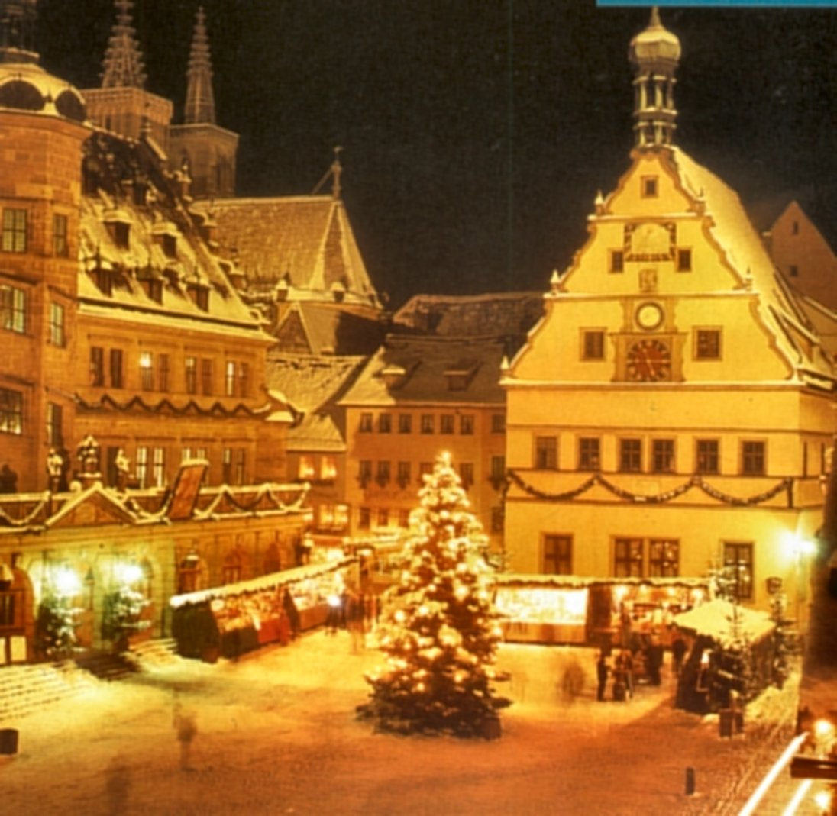

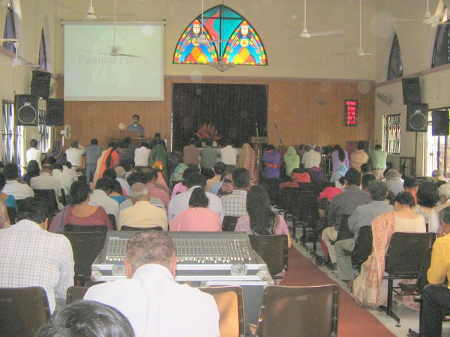

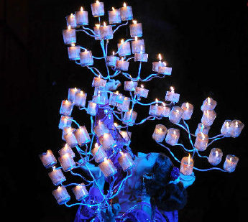


Where the performers will send you into tailspin!!!

Agile acrobats on trapezes, daredevil motorbike riders and supple gymnasts beckon audiences with an assortment of feats at the Gemini Circus.
The artists in their glittering outfits present three shows every day. Visitors are assured of a visual treat inside the circus.
A large number of the artists are from Nepal says Mr.Chandrashekar, the Circus Manager. A group of Russian artists are to join them soon he adds.

An artist performs an elaborate dance with lamps at the Gemini Circus in Chennai.

Ice Creams Galore

Nick and Baskin Robins have come with a new flavour – Nick Orange flavour to celebrate Christmas and New Year.

Tiny Tots celebrate the ‘Season of Love’

Children from orphanages and children’s homes had a rocking time at the fun festival organized by the Tamil Maiyam. A feast of food, music, dance and games delighted 2700 children at the St. Bedes’ Anglo Indian School grounds. Several entertainment stalls lined the ground, which was decked up for the event.
A group of tiny tots, who are in a transit school for children of construction workers, wore masks and costumes for their first-ever cultural programme. Andrea and group hosted a Salsa dance performance. Contributions from sponsors were used to give dinner packs, a set of New Year clothes and a gift bag of toys for each child. The team reached out to another set of 2000 children who were not attending the event by going to orphanages and welfare homes.

Escape to an entertaining world!!!

Fun with the fab four.
ENTERTAINMENT
Madagascar: Escape 2 Africa is a perfect holiday movie. There is the right amount of fun, set pieces, energy and fun to keep every age group entertained. The storyline goes something like this: The fab four crash land in Africa for a “ROOTS” style reunion. There are penguins, lemurs, elephants, tourists and ofcourse, Nana, who packs a preety mean punch.

The voice cast is cool from Ben Stiller as Alex and Chris Riock as Marty to Sacha Maron Cohen as the strangely Indian sounding King Julien.

At under 90 minutes, Madagascar: Escape 2 Africa is an engaging and entertaining ride.

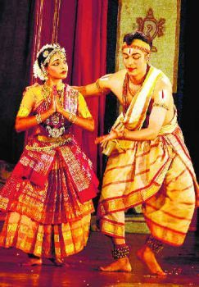
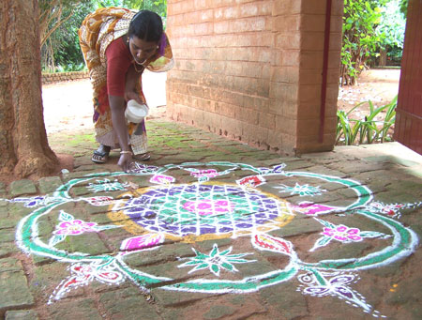
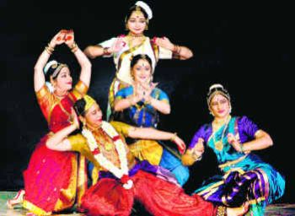
MARGAZHI FESTIVITY
Margazhi – A Unique Month

The Tamil calendar is punctuated with festivals. In no other month does the festival mood spreads unbroken over one full month like Margazhi. The month of Margazhi is unique. The atmosphere is suffused with religious fervour and sanctity that draws people from different sections of the community. `Among the months, I am Margazhi,' said Lord Krishna in the Gita. Wrapped in shawls, people join bhajan groups and go round the streets, unmindful of the cold and nipping air. Womenfolk, particularly in villages and small towns, decorate the front yard and the streets with striking kolams made of rice flour. Devotees rush to listen the discourses on Tiruppavai. The discourses provide the spiritual diet, while pongal spiced with ginger and pepper satisfies their palate. Religious discourses are then supplemented and/or complemented by music and dance in sabhas of which there is no dearth. In fact, one can, if one chooses, spend every day in the month of Margazhi listening to discourses and music. The old is ever new. The members of the community relive and re-enact the experience of the ages to renew, rejuvenate and fortify their faith and devotion.
Tribute to MS
As part of an initiative by Vasantha Memorial Trust, an organisation for cancer care and cure, to propagate the music and memories of the legend, M. S. Subbulakshmi, Amrita Murali performed a special concert on ‘Ram the Subbulakshmi Way’ on November 16, at the Vasantha Memorial Cancer Centre. On the occasion, Seetha Ravi, editor, Kalki, and grand-daughter of MS, shared her experiences about the legend.

Andal Charitram

Kalakshetra presented "Andal Charitram," a dance-drama produced by Rukmini Devi Arundale in 1961. The neat adavus and group coordination, not forgetting details such as kicking up the heels when walking, the `kuluku' of Bharatanatyam, the deep square araimandi, were a treat. As was the authentic music, composed by Papanasam Sivan. The dancers negotiated the performance area with ease. Rukmini Devi's genius for group formations was visible in the variety introduced in the scenes with Andal and her sakhis, where six dancers were divided into all possible numerical combinations. Also, no monotony was allowed to settle while conveying the content of the lyrics.
Beckoning Krishna

It seems a healthy trend that dancers from different backgrounds, trained under different gurus, come together to present programmes. The other day, Meenakshi Chittaranjan, Uma Muralikrishna, Gopika Verma and Srilatha Vinod presented `Krishna Nee Begane Baro'.
The first presentation was based on the famous composition `Krishna Nee Begane Baro.' While Meenakshi and Srilatha presented Bharatanatyam, Uma represented Kuchipudi and Gopika, Mohiniyattom. The dancers took up a stanza each for elaboration in their own style. Aparna Chittaranjan, Meenakshi's daughter, played the role of Krishna. With an aesthetic tableaux and music of the traditional piece arranged for a group presentation, some of the potential of the piece was lost due to harsh amplification. The rest of the programme comprised solo presentations by each dancer.

tggfcfhfgfg
Aries 2009 Horoscope : You will have an aggressive spirit and will have an interest in social work and political activities. You are disposed to injury in the head and face.
Taurus 2009 Horoscope : You will have a highly endowed mind possessing creative fancy, intuitive faculty and fondness for artistic pursuits. You will have an amiable disposition and steadfast affections.
Gemini 2009 Horoscope : You will have sharp intellect, humane nature and generous disposition. You will possess a high degree of self-esteem and brimming confidence; you will be capable of rising in life by dint of merit alone.
Cancer 2009 Horoscope : You will be a person of kind and attractive nature, amiable disposition and generous character. You will have a social standing and may have some success in artistic field.
Leo 2009 Horoscope : You will have a strong, careful, forcible and watchful nature. You are laborious and possess and austere uncontrollable character.
Virgo 2009 Horoscope : You will have a long life and have interest in study of theoretical/ analytical sciences and applications, oriented subjects like Technology or Engineering.
Libra 2009 Horoscope : You will have a genial but weak nature, fairly disposed to extravagance and unsteady habits. You are likely to have change in pursuits but still be clever in business dealings.
Scorpio 2009 Horoscope : Your nature is strong, forceful and energetic, capable of immense feats of prowess and endurance. In strife, you will be implacable, scorning defeat.
Sagittarius 2009 Horoscope : You will have a sober mind, good judgment and a quick intellect. But richness of intellect and lack of concern for method may lead you to profusion and disorder.
Capricorn 2009 Horoscope : You are masterful and ambitious, but often your mind gets beclouded with doubts. You are not very broadminded because of being a strong sectarian and disposed to religious austerities.
Aquarius 2009 Horoscope : You are a sober and placid in temperament, devoid of unruly passion and excess. You will figure in institution reunions and social gatherings.
Pisces 2009 Horoscope : You will have religious spirit and an inclination to extremism and fanaticism. You may have disputes and quarrels with powerful enemies.

PREDICTIONS FOR 2009

Celebrations everywhere to welcome 2009!!!
WELCOME 2009!!!

New Year’s Reality Check
Another year, another chance
To start our lives anew;
This time we’ll leap old barriers
To have a real breakthrough.
We’ll take one little step
And then we’ll take one more,
Our unlimited potential
We’ll totally explore.
We’ll show off all our talents
Everyone will be inspired;
(Hmm…while I’m writing this,
I’m getting very tired.)
We’ll give up all bad habits;
We’ll read and learn a lot,
All our goals will be accomplished,
Sigh...or maybe not.
Oh well, Happy New Year anyway!

Pieces of Time
New years come and new years go,
Pieces of time all in a row.
As we live our life, each second and minute,
We know we’re privileged to have you in it
Our appreciation never ends
For our greatest blessings: our family and friends.
Happy New Year!

People Like You
A brand new year!
A clean slate on which to write
our hopes and dreams.
This year:
Less time and energy on things;
More time and energy on people.
All of life’s best rewards,
deepest and finest feelings,
greatest satisfactions,
Come from people--
People like you.
Happy New Year!

In The New Year
In the New Year,
we wish you the best year you’ve ever had,
and that each New Year
will be better than the last.
May you realize your fondest dreams
and take time to recognize and enjoy
each and every blessing.

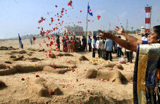
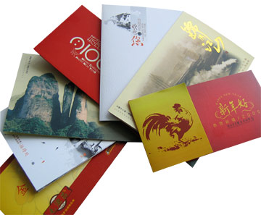

Beaches witness waves of memories

Thousands of people gathered near the seafront to pay homage to the victims of the killer waves, tsunami that claimed hundreds of lives on the 26th December four years ago.

Fishermen and residents in large numbers gathered around the Elliot’s and Marina beaches to pay tribute to the victims.

Messages such as “Tearful homage to our dear relatives and friends” were written in bold letters on the Elliot’s Beach Road.

“We are struggling to cope with the aftermath of the tragedy. Some of us women are a part of self-help groups, formed as part of the rehabilitation measures, but we don’t earn too much of money” says Gomati.

Members of the fishermen’s associations took out silent rallies, lit candles and paid homage to their colleagues who lost their lives to the tsunami.

The fishermen agree that it is not something that they can forget or overcome easily. Even today they are scared to venture in the sea on the 26th of December.

On the Marina, a few sand sculptures were made and black coloured flags were hoisted to mourn and pray for the victims.

Tearful recollection: Sand sculptures were made on the Marina Beach on the fourth anniversary of the Tsunami.
HERE & THERE
Greeting cards hold their own

Despite the stiff competition from new-age rivals such as e-cards and text messages, greeting cards seem doing well, if the scene at post offices in the city is any indication.
Officials of the Department of Posts said that on an average, 50 lakh greeting cards get posted in the city during the festive season in December and January. This year, the figure is expected to double, with more people opting to send greeting cards to add a personal touch to their wishes. People may drop their greeting cards in special letterboxes set aside for them. The service of sorting the greeting cards helps to deliver in 24 hours. Infrastructure has been strengthened in the section created to sort cards sent from corporate houses to customers.
“We have introduced pick-up service for bulk delivery of cards this year. More franking machines have been provided to take up the additional load of mails,” Mr. Venkataraman says.
“The cost of sending greeting cards by post is only Rs.4 for across the country. Ten student volunteers are involved in sorting the cards, and they are paid on a weekly basis,” says R. Jayaraman, Senior Post Master, T. Nagar Head Post Office.

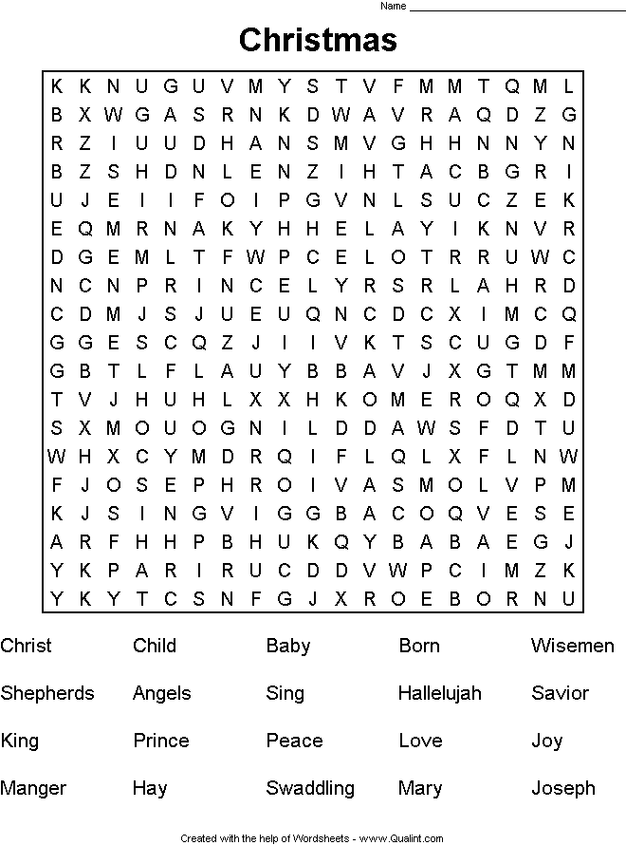
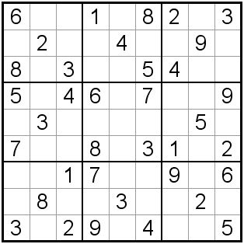
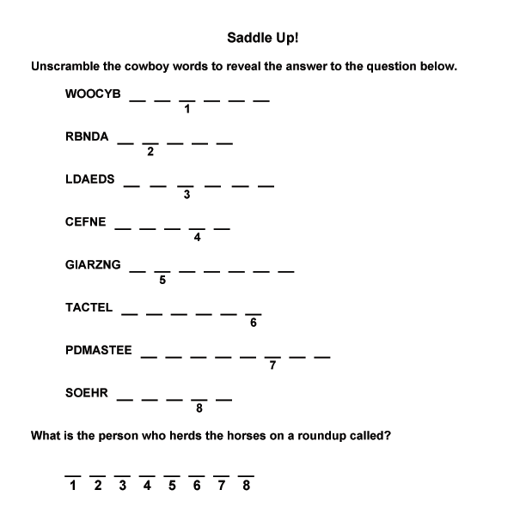

ENJOY & RELAX!!!

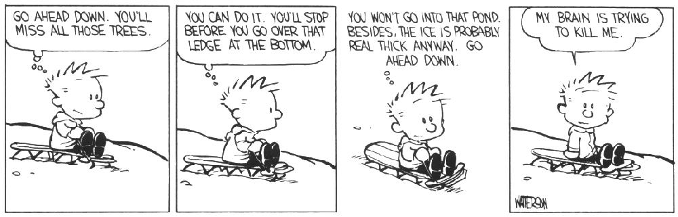
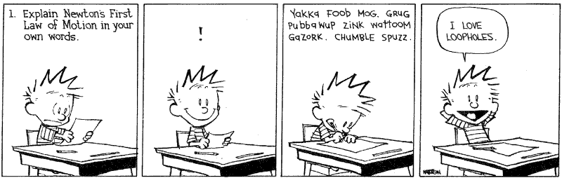
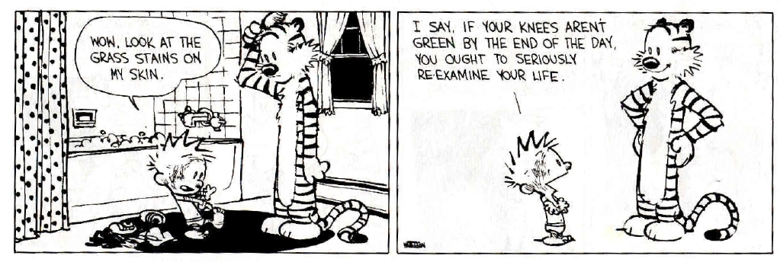
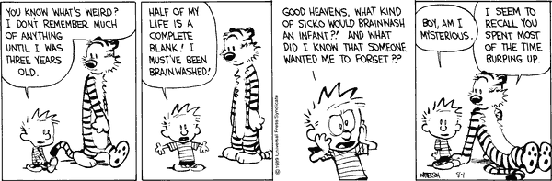
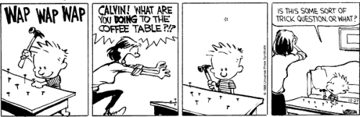
ENJOY & RELAX!!!

