About our school!

Our teachers!

In our school we have over 27 teachers. Our year 5 teachers are Miss Riley and Mr Evans.
Our lessons!

Our main lessons are maths, literacy, science, history, P.H.S.E, p.e, Spanish art, R.E, geography and ICT. We do 5 lessons in a day.
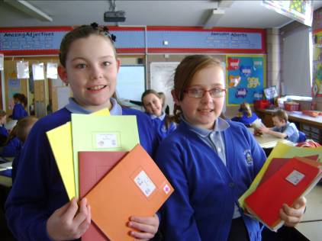

Our playground!

We are lucky to have a playground like we have because we have got a tyre park, trolley, massive field, football pen, seating area. The seating area is quite new and so is the trolley. Lots of people play football in the pen especially year 5/6; it’s mostly boys that play in the team to practise some girl’s play in the football team.
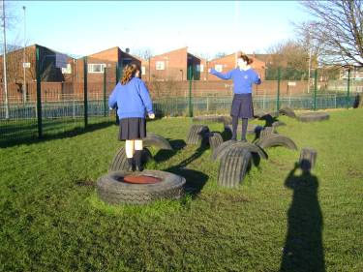
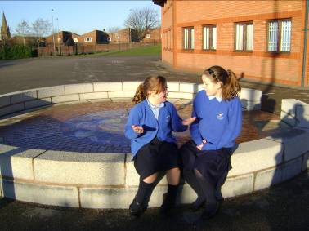
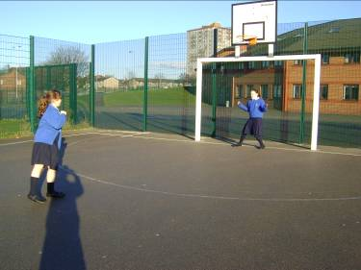

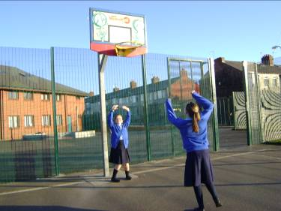
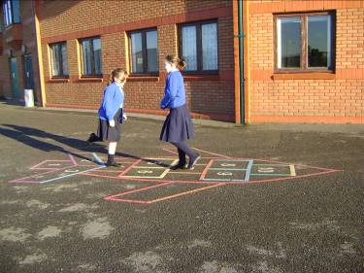
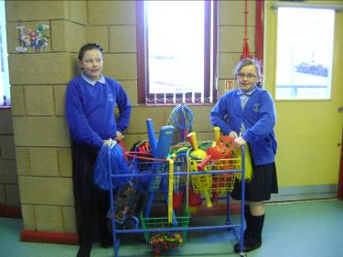

All our Clubs

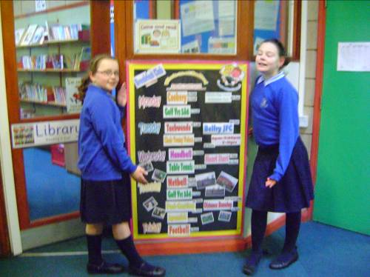
In our school we have several in school time and after school. Our school finishes at 3:10, so most after-school activities start at 3:15/3:20. We have about 2 in time school activity its called gardening club and breakfast club. All are after-school clubs are called choir, tri-golf, football training, pod-casting, netball, Spanish club, table tennis, taekwondo, handball, running club, cookery, badminton, heart start, Spanish club and running club.

Golden time!!!

During golden time we get to play various activities with fellow classmates. Golden time is a time where we get to talk with our friends and play some games, board games. These are all the things we get to do: draw on paper with felt-tips and coloured pencils, go on the teachers laptop and smart board- maths games- smart notebook- radio waves, white board. Some golden times Mr. Evans takes us out onto the playground with the trolley.

Monitors!!
In our class we have monitors and everyone in our class has a job.

Assembly awards!!
In assembly we have lots of awards like student of the week, student of the month.

Different cultures

In our school we love learning Spanish! Some of us also go to Spanish club which is after school where we learn about everything to do with Spain. Some children were also very lucky to travel to China this year!
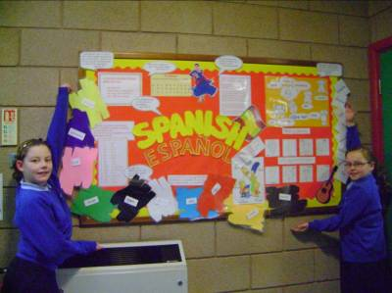
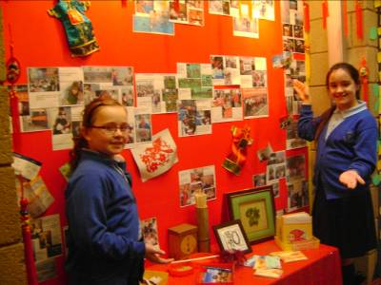

Liverpool Capital of Culture!!

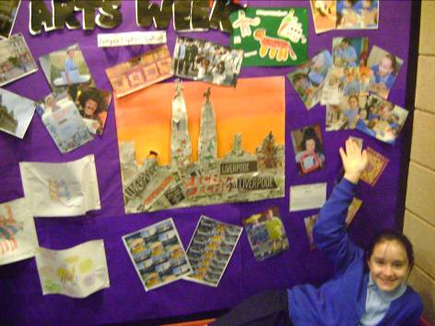
To celebrate Liverpool being Capital of Culture 2008 we took part in a Liverpool themed arts week. During this week we did lots of activities including singing, making collages, cooking, rapping and a quiz.

