Roads in Saudi Arabia

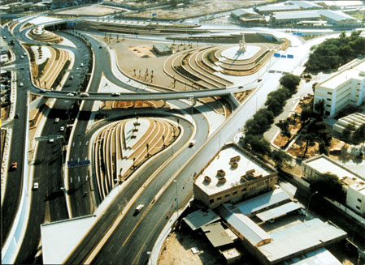
The roads in Saudi Arabia are very modern and well organized. Cities are connected through these roads. The government spends millions of Saudi Riyals for developing these great road networks. A sample of these roads is shown below.

Done by: Usama

