Olive and Olive Oil
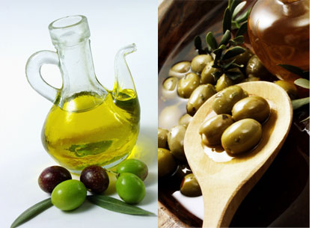

It's commonly known as the golden liquid for its magnificent color, it’s really good. It differs from all other oils and more healthy. It can be added to many kids of food. Moreover; it can be used as moisture for the human skin.

The olive itself is a full healthy, nutritious food. It is rich in vitamins. People in Saudi Arabia love it very much and eat it every now and then.

