French fries
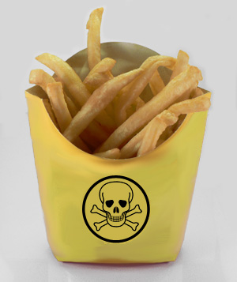

Aha!! This is one of the reasons that made people fat; it might be tasty and good looking but it's like a poison that you eat. Potatoes contain a lot of fiber and other stuff that are good for the human body, but the oil will strip down its good nutrients.

