SOSIALISASI FOR THE ENGLISH TEACHER OF PMH PUTRA
IN LANGUAGE LABORATORY OF PMH Putra ISLAMIC BOARDING SCHOOL
ON NOVERBER 10TH 2008
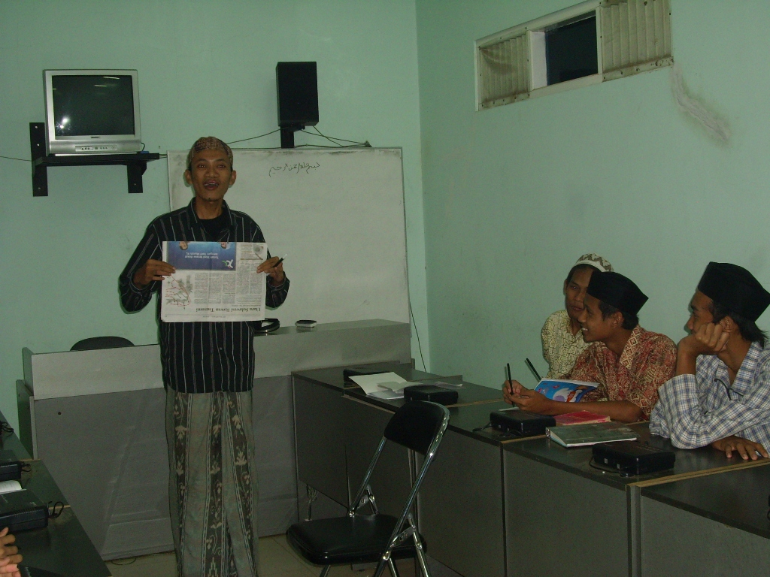

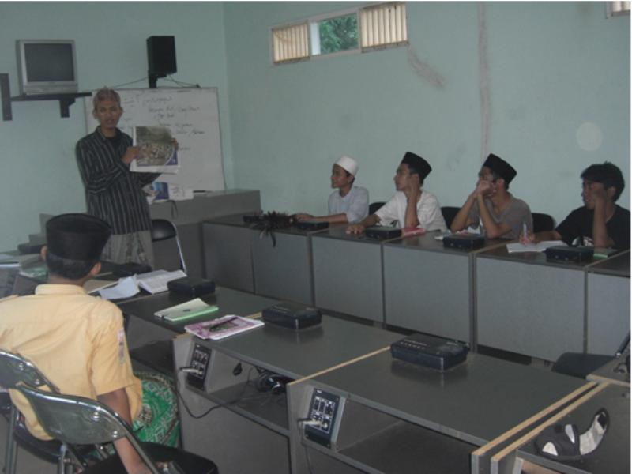

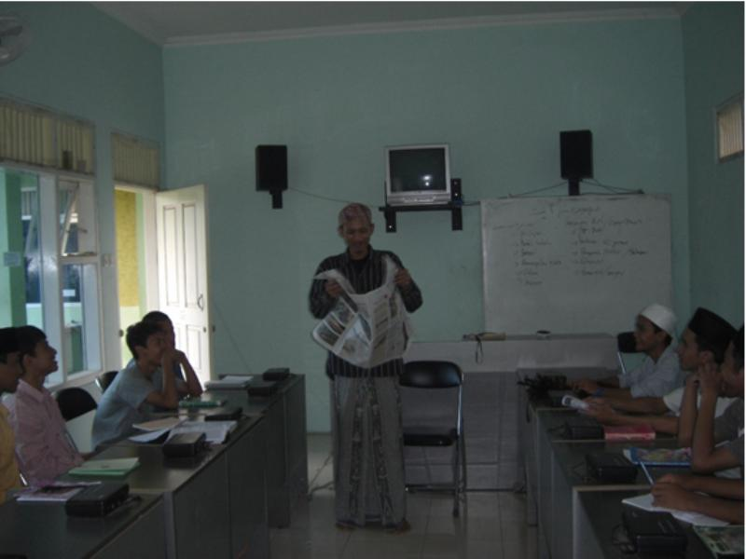

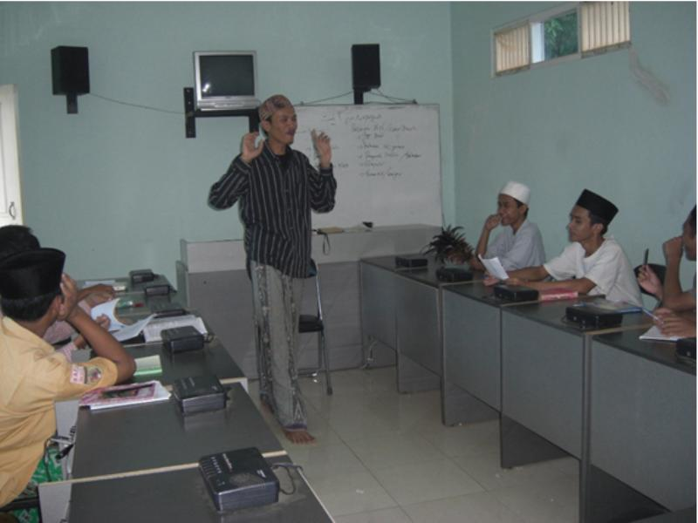

SOSIALISASI FOR THE ARABIC TEACHER OF PMH PUTRA
IN AUDITORIUM OF PMH Putra ISLAMIC BOARDING SCHOOL
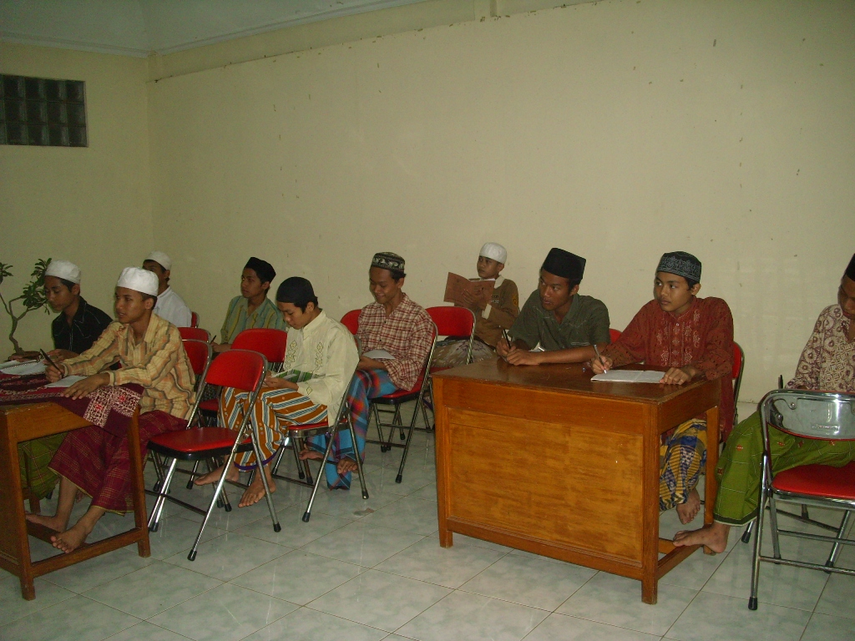

SOSIALISASI FOR THE ENGLISH TEACHER
IN AUDITORIUM OF PESILBA ISLAMIC BOARDING SCHOOL
ON NOVEMBER 15th 2008

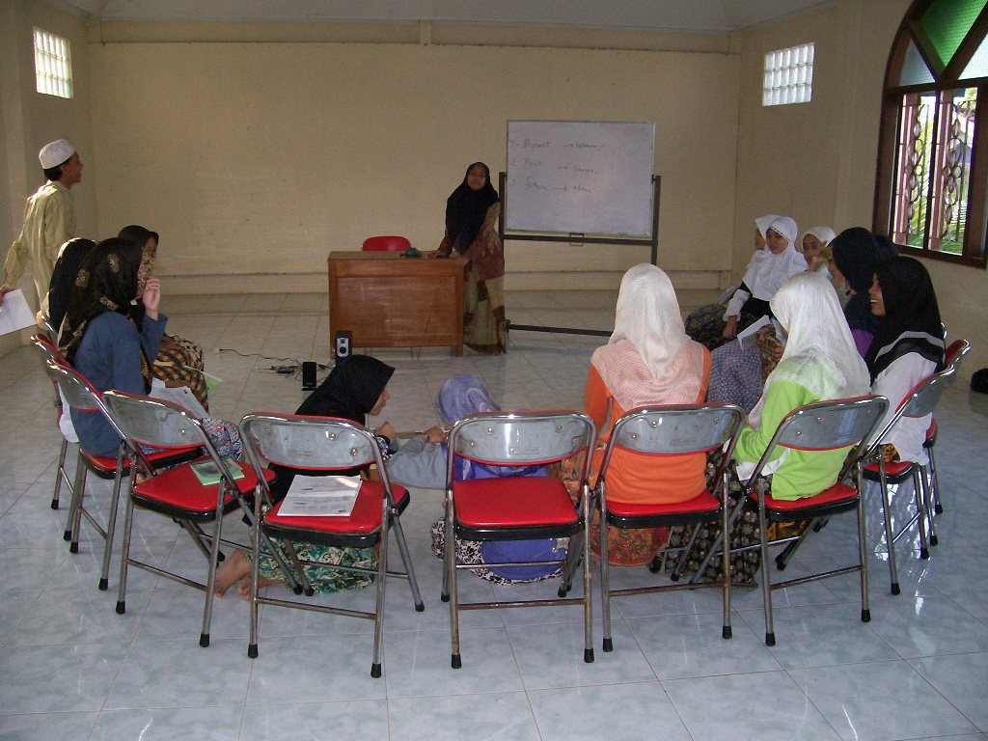

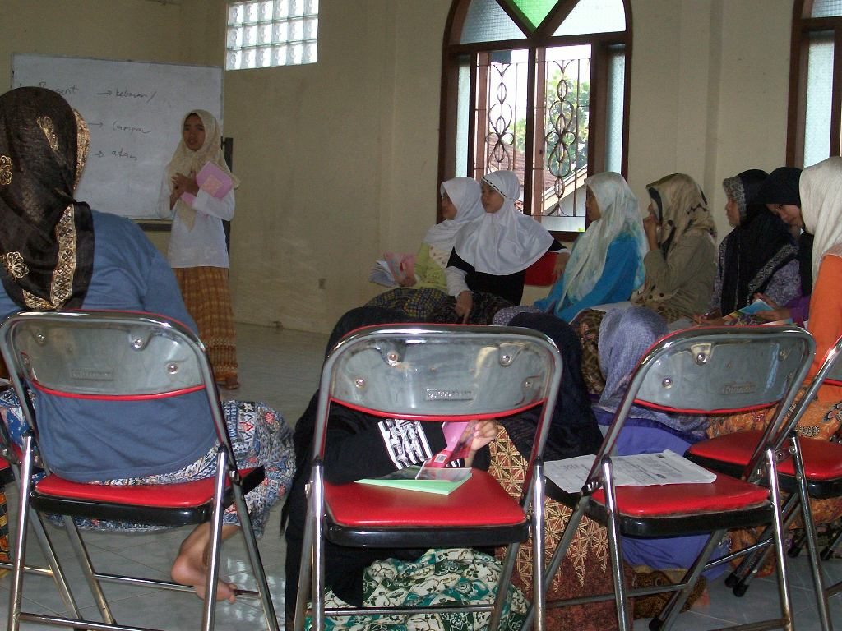

SOSIALISASI CLASSROOM OF BRITISH COUNCIL FOR PMH Putra AND PESILBA ISLAMIC BOARDING SCHOOL.
Kajen, November 10th and 15th 2008
We make sosialisasi a classroom of british council in 2 intsitution, PMH putra and Pesilba (especially for ladies) islamic boarding school that have 2 languages between English and Arabic.
That way, we carry out this program for 2 languages too. The participant are all of the tutors or teachers for English and Arabic program in every islamic boarding school with difference place and time for training. We give them all of the matters and some new methods of teaching that has got in the british council. So sure, that method can receive well.
There are 33 participants for PMH Putra Islamic boarding school and 25 participants for Pesilba Islamic Boarding School. And now, that method has applied in every islamic boarding school when we see and get report. Thank very much, british council.

