
Camels
Camels are herbivores; they eat desert vegetation, such as grasses, herbs, and leaves.
How do camels adapt to their environment?
Camels have many adaptations that allow them to live successfully in desert conditions. Deserts are hot and dry. Winds blow sand all around, so a camel has long eyelashes. It has nostrils that can open and close.
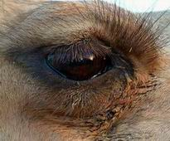
Why do camels have long eyelashes?
The long eyelashes keep sand out of the camel's eyes.
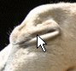
Thick eyebrows shield the eyes from the desert
sun.
Why does a camel have nostrils which can close?
A camels nostrils can close so it doesn't get sand up its nose.
Other Adaptations:


1. A camel can go a week or more without water, and they can last for several months without food. They can drink up to 32 gallons (46 litres) of water at one drinking session!
2. Camels store fat in the hump, not water. The fat can be metabolised for energy.
3. Unlike most mammals, a healthy camel's body temperature fluctuates (changes) throughout the day from 34°C to 41.7°C (93°F-107°F.) This allows the camel to conserve water by not sweating as the environmental temperature rises.
4. Camels feet are wide so they can walk on sand more easily. Their huge feet help them to walk on sand without sinking into it.
5. Camels have thick lips so they can eat the prickly desert plants without feeling pain.
6. The color of their bodies helps them to blend into their environment.
7. Camel's ears are covered with hair, even on the inside. The hair helps keep out sand or dust that might blow into the animal's ears

