National Parks in Montana

Big Hole National Battlefield
Wisdom, MT

Glacier National Park
Northwest Montana, MT

Grant-Kohrs Ranch National Historic Site
Deer Lodge, MT

Yellow Stone National Park
Yellowstone National Park, ID, MT, WY

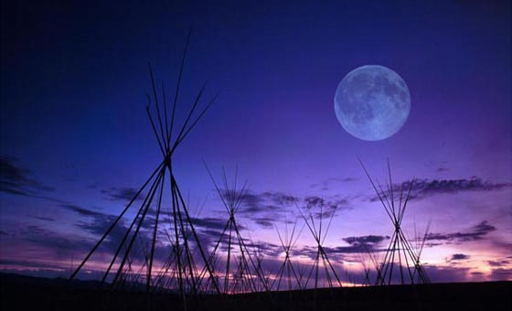

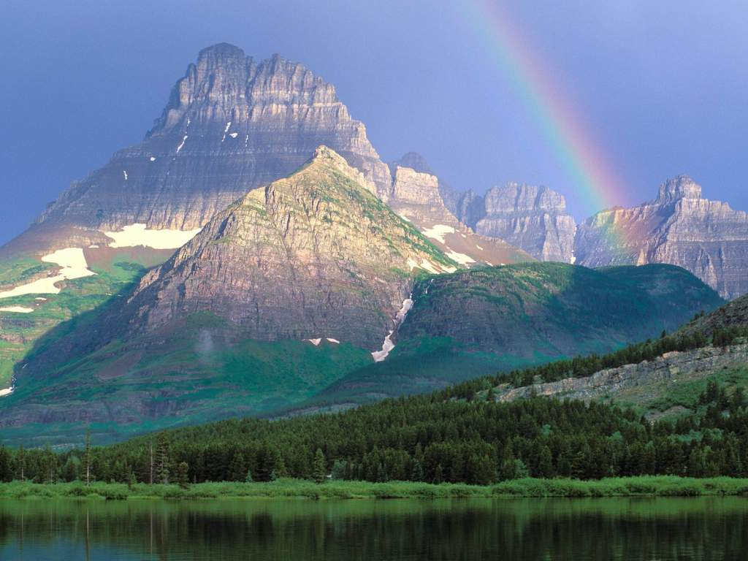
Within the Big Hole National Battlefield is the Nez Perce National Historical Park. This park is “a park about a people for all people.” It commemorates the legends and the history of the Nez Perce and their interaction with others.

This park is a camp with “pristine forests, alpine meadows, rugged mountain, and amazing lakes.” It has over 700 miles of trails.

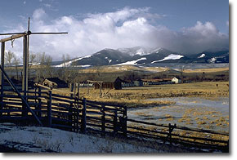
Once the headquarters of a 10 million acre cattle empire. It is a working cattle ranch that preserves these symbols and commemorates the role of cattlemen in American history.
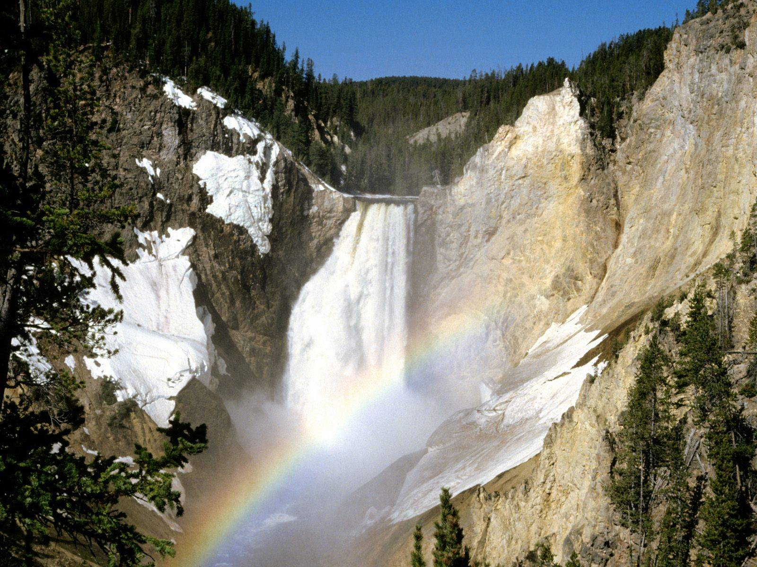

Yellowstone National Park is America's first national park. Old Faithful, the most popular geyser in the world, is one experience that you can’t miss.

