Yellowstone National Park, Yellowstone National Park, ID, MT, WY This national park is America’s first national park. It spreads to Idaho, to Montana, and to Wyoming. It has many different varieties of wildlife, such as, bison, elk, moose, grizzly bears, coyotes, and wolves. There are many rare and beautiful geysers located here, Like Old Faithful. There is also a canyon called the Grand Canyon of Idaho.
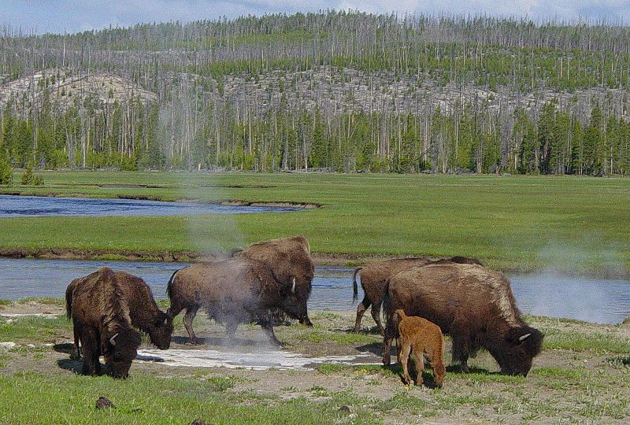

Hagerman Fossil Beds National Monument, Hagerman, ID
This national monument has many rare and extraordinary fossils. There are over 220 fossil deposits of different plants and animals here.
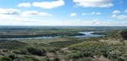

Nez Perce National Historical Park , four different states, ID, MT, OR, WA
The Nez Perce have lived alongside the inland northwestern prairies, rivers and canyons. This park shows the story of the Nez Perce, a group of people who are still around today.

Oregon National Historic Trail , many States, ID, KS, MO, NE, OR, WY
Over 2,000 miles of traces and trail ruts are viewed in large western areas. The Oregon Trail was a path for many different early American voyagers. The Oregon Trail is still around today, for people to explore in the footsteps of travelers that journeyed through here many years ago.

Emily Smith 21

