National Parks of New Hampshire

The White Mountains National Parks- there are trails, scenic drives, historic places and plenty of places just to relax. Archaeological testing has shown that there have been 21 Native American sites here. The Whites has a lot to offer!


Appalachian National Scenic Trail- America’s first National Scenic Trail. It runs from Maine to Georgia. It runs 2,174 miles. It was opened as a continues trail in 1937

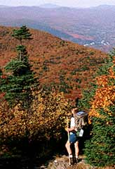

Saint Gaudens National Historic site- the beautiful homes studio gardens of Saint Gauden- one of America’s greatest sculptors Over 100 pieces of his artwork can be seen in galleries. Take sculpting classes, enjoy nature trails or indulge in concerts. An entrance fee of $5.00 is for visitors of 16 years or over. 

Bear Brook State Park- It is the largest developed state park in New Hampshire. Hiking, biking and swimming are just a few things to do here. Archery Pond is welcome to all enthusiastic fly fishers! If Archery is the sport for you than you should be happy to know that Bear Brook has two archery ranges. If you are worried about being a couch potato on your vacation then don’t worry because Bear brook has a 1-1/4 mile, 20 station fitness course!


