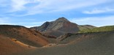 Halekala National Park , Kula, Maui, HI
This park cares for endangered species some of them only exist here. It has landscapes of volcanoes and sub-tropical rainforests.

Hawaii Volcanoes National Park, Hilo, HI
This park has two of the world’s most active volcanoes.

Kaloko-Honokohau National Historical Park - Kailua-Kona, HI
It is made up on stark fields of lava.Ancient Hawaiians had a spiritual reason for settling here.

Kalaupapa National Historical Park - Kalaupapa, HI
This was the place where Hawaiians with leprosy were forced to go from 1866 until 1969 so that they wouldn’t spread the disease to others.

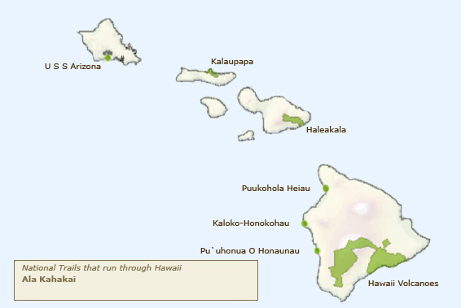

Emily Smith 21

