England National Parks

Northumberland National Park- It covers an area of more than l030 km2 between the Scottish border in the north and Hadrian’s Wall. It is one of the least populated and least visited of the National Parks. The park covers about a quarter of the country. The park has many distinctive areas, one of them are the Cheviots, hills that mark the border between England and Scotland.

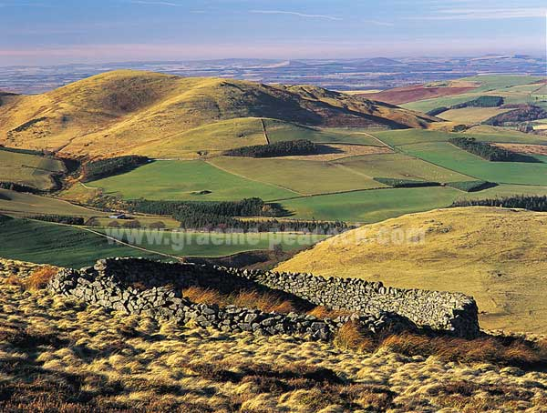

Lake District- Lake District is one of England’s most popular and biggest national parks. It is 34 miles across and is home to many plants and animals. It also includes the Scafell Pike, England’s highest mountain. Lake District has over 14 lakes. Its mountains and hills are beautiful and perfect for any mountain climbers, hikers, wildlife photographers, and people who are looking for some where quiet and peaceful to spend their day.

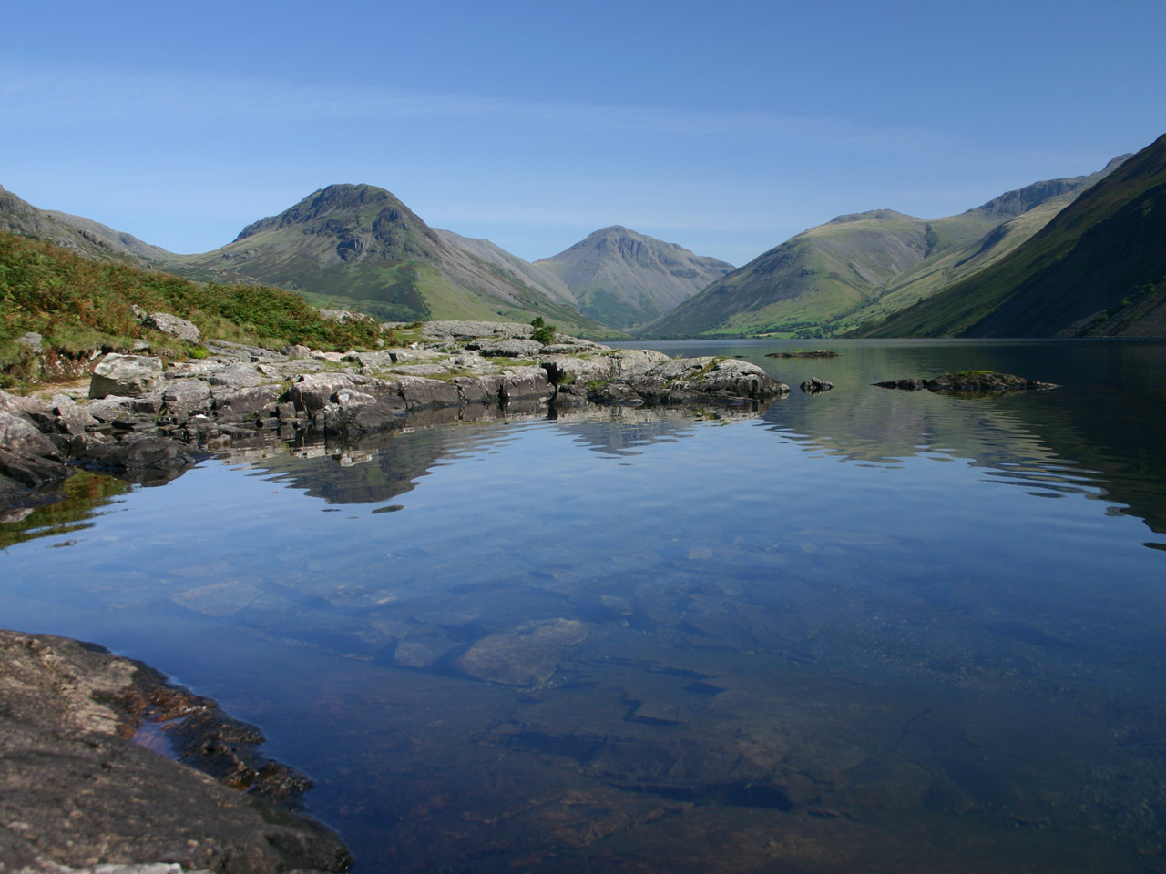

North York Moors- the North York Moors is in North Yorkshire, England. It has one of the largest expanses of moorland in the United Kingdom. It stretches about 554 miles. It became a national park in 1952, through the National Parks and Access to the Countryside Act of 1949.

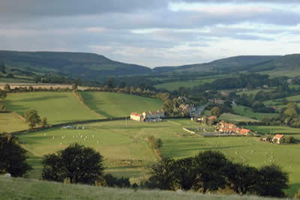

Yorkshire Dales- Established in 1954, the Yorkshire Dales National Park has beautiful scenery and hosts many different types of wildlife. Covering an area of 680 square miles, the national park is located in the north of England.

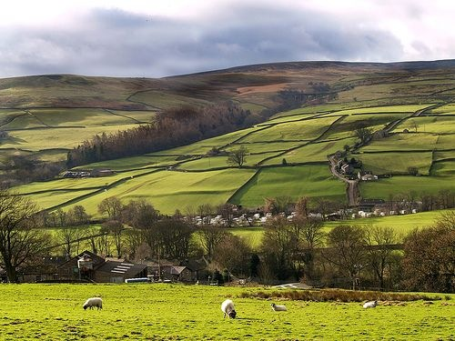

Peak District- it was Britain’s first national park, established in 1951, and is visited by people all over the world. They come to find peace, tranquility and adventure, experiencing some of England’s finest climbing, caving, walking, and cycling. The national park is also home to 38,000 people.
