Koli National Park

Urho Kekkonen National Park

Oulanka National
Park

Deanna Bono 2
4/18/09

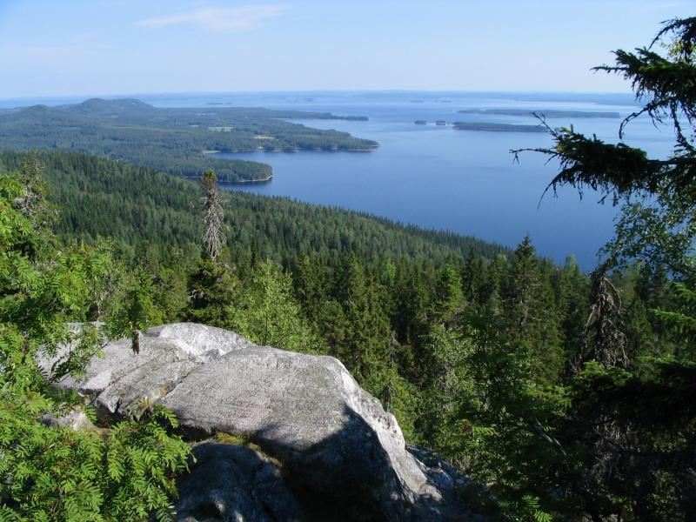

It was a sacrificial site. Then later, it was used for slash-and-burn agriculture. The point of it isn't to reserve wild nature but for traditional agricultural heritage.

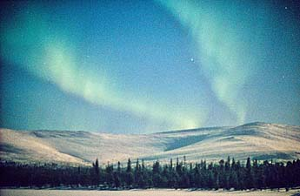
It is one of Finland's largest protected areas and was named after former President and Prime Minister of Finland, Urho K. Kekkonen.

This Park rich in animal and plant species, even endangered ones. It has pine forests and river valleys with sandy banks and rapids. It is one of the most popular national parks in Finland.

