Greece National Parks

The National Park of Ainos- is perhaps the oldest nature preserve in Greece. Although it does not have many exotic plants and animals it has value in variety. It was originally covered by a dark forest but overtime uncontrolled cuts of wood and a great fire have reduced the plants to one quarter of its original size. The national park of Ainos was created to protect this amazing and unique forest.
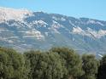

Olympic National Park- has more than 3,000 miles of streams and rivers, many lakes and about 53 miles of wilderness coast. It is a place that will take your breath away and will leave you wanting more.


Iti National Park- has a big variety of trees, plants and animals that make it very unique and interesting environment. The national park is within Mount Iti, which is famous for it’s many birds.
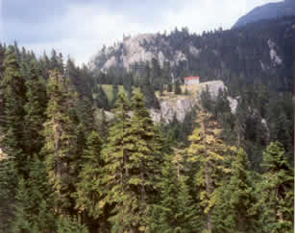

Sounio National Park- is the smallest of the national parks. It is revered for its beauty and wonderful scenery. It is sitting in the glow of The Temple of Poseidon.
