The National Parks of Ireland
Glenveagh National Park
Glenveagh National Park is in the Derryveagh Mountains in the north-west of County Donegal. It is a beautiful wilderness of mountains and lakes. The Park, over 16,000 hectacres consists of three areas. The largest of these is the former Glenveagh Estate, including most of the Derryveagh Mountains. To the west are the hills around Crocknafarragh and to the south, the Lough Barra bog, Meenachullion and Crockastoller. Glenveagh has many rare and interesting plants and animals and is famous for its red deer. The Park contains the peaks of the two highest mountains in County Donegal, Errigal (752m) and Slieve Snaght (683m.)A fine Victorian castle surrounded by beautiful gardens is located on the eastern shore of the lake and provides the focal point for visitors to the Park. The last private owner Henry P. McIlhenny donated the castle, including much of its contents in 1983. The Park and gardens were officially opened to the public in 1984 and the Castle in 1986.
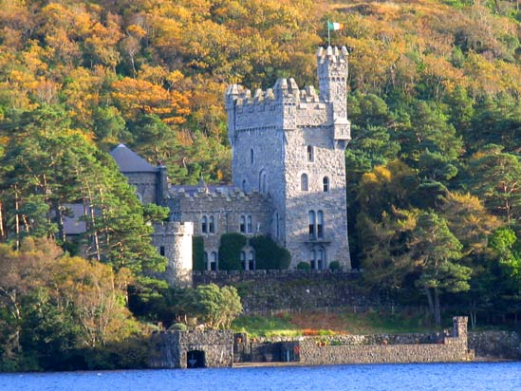
Ballcroy National Park
Ballycroy National Park was established in November 1998, it is Ireland’s sixth National Park and is located on the Western seaboard in northwest Mayo. It is 11,000 hectares of bog and terrain, covering a vast uninhabited wilderness dominated by the Nephin Beg mountain range. To the west of the mountains is the Owenduff bog. This is one of the last intact active blanket bog systems in Ireland and Western Europe and is an important scientific feature of the National Park. The Park also protects a variety of other important habitats and species. These include alpine heath, upland grassland, heath and lakes and river catchments. Greenland White-fronted geese, Golden plover, Red Grouse and Otters are just some of the important fauna found within the Park. The National Park is itself part of the Owenduff/Nephin Complex Special Area of Conservation (SAC) and Special Protection Area (SPA).
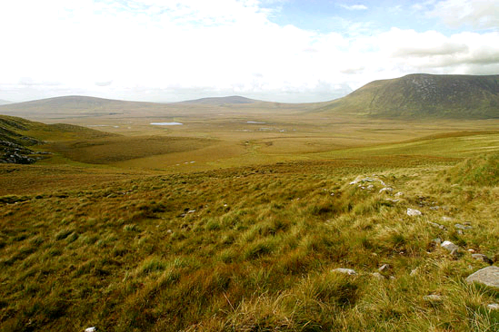
Conemara National Park
In the West of Ireland in County Galway, Connemara National Park covers 2,957 hectares of mountains, bogs, heaths, grasslands and woodlands. Some of the Park's mountains, Benbaun, Bencullagh, Benbrack and Muckanaght, are part of the famous Twelve Bens or Beanna Beola range. Connemara National Park was opened to the public in 1980. Much of the present Park lands formed part of the Kylemore Abbey Estate and the Letterfrack Industrial School, the remainder having been owned by private individuals. The southern part of the Park was at one time owned by Richard (Humanity Dick) Martin who helped to form the Society for the Prevention of Cruelty to Animals during the early 19th century. The Park lands are now wholly owned by the State and managed solely for National Park purposes.
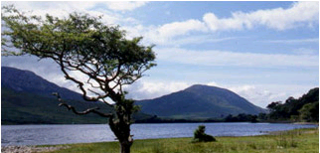
The Burren National Park
The Burren National Park is located in the southeastern corner of the Burren and is approximately 1500 hectares in size. The Park land was bought by the Government for nature conservation and public access. It contains examples of all the major habitats within the Burren: Limestone Pavement, Calcareous grassland, Hazel scrub, Ash/hazel woodland, Turloughs, Lakes, Petrifying springs, cliffs and Fen.
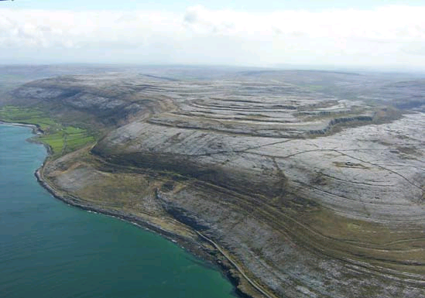
Wicklow Mountains National Park
Wicklow Mountains National Park covers part of a mountain range that extends over most of County Wicklow on the east coast of Ireland. The upper slopes are heath and bog. There are also forestry plantations and the winding mountain roads. Fast-flowing streams go into the deep lakes of the wooded valleys and continue their course into the bottom of the mountain the primary purpose of Wicklow Mountains National Park is the conservation of local landscape. The Park is also a space for locals and visitors to come to. Over one million visits are estimated to be made each year. The most visited area is the Glendalough Valley where the ancient settlement of St. Kevin is located.
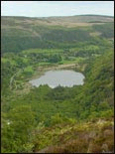
Killarney National Park
South and west of the town of Killarney in Co. Kerry is an expanse of rugged mountainous country. This includes the McGillycuddy's Reeks, the highest mountain range in Ireland which rises to a height of over 1000 meters. At the foot of these mountains there is the world famous Lakes of Killarney. Here where the mountains sweep down to the lake shores, their lower slopes covered in woodlands, lies the 10,236 hectare (26,000 acres), Killarney National Park. The mountains, lakes, woods and waterfalls under ever changing skies gives the area a special beauty. The main part of the National Park for visitors is Muckross House and Gardens. Killarney National Park contains important historical sites such as the native oak woods and yew woods together with an abundance of evergreen trees and the native red deer are unique in Ireland.
