**Northumberland National Park**

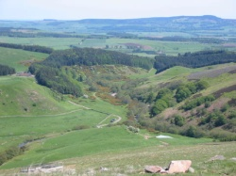

**The park was established in the year of 1956. The main settlements of the park are Haltwhistle, Bellingham, Rothbury, and Wooler. The area of the park covers 405 square miles. It stretches from Hadrians Wall to the Cheviot Hills on the border of England and Scotland. It is one of the least populated and least visited out of the National Parks.**

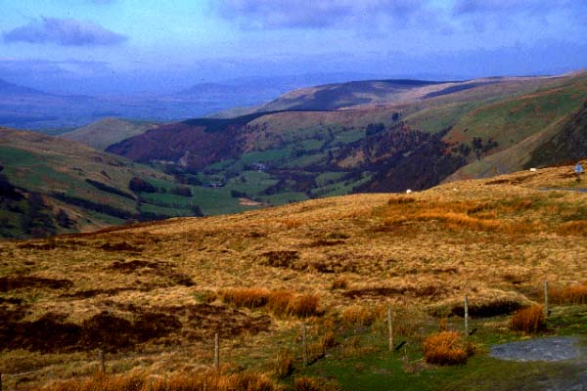

**Snowdonia National Park**

**The park was designated in 1951. It was the third park to be created in Wales and England. It is the second largest park in Wales and England. The area of the park covers 840 square miles. Some mountains that are in the National Park include the Snowdon Massif, the Glyderau, and the Carneddau. These are the highest mountains in Wales.**

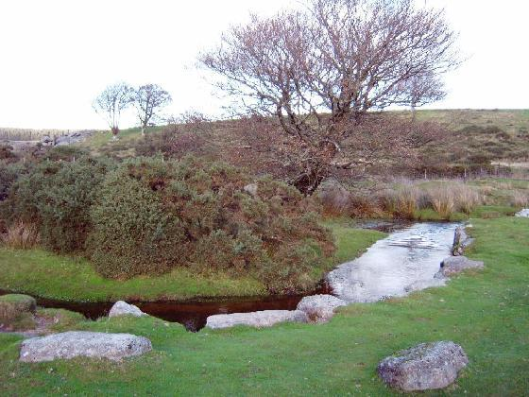

**Dartmoor National Park**

**The park was designated in 1951. The population consists of 29,100. It is located in Devon, England. Dartmoor National Park is known for its tors. The best known tor on Dartmoor is Haytor, which is 1,500 feet. The area of the park is 368 square miles. The National Park passes through marshy valleys, soil, grasses, heather, and bracken.**

**The park was designated in 1954. The main settlements are Lynton, Dunster, Porlock and Dulverton. The population consists of 10,600. It is situated on the Bristol Channel coast of south west England. The area of the national park is 267 square miles. It goes by beautiful farms, valleys, and plateaus.**

By: Alexis Ahern

**Exmoor National Park**

