New York

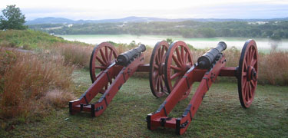
Saratoga National Historical Park
- Location: 40 miles north of Albany and some 15 miles southeast of Saratoga Springs
- Fact: In the autumn of 1777 American forces joined at this spot and forced a major British army to surrender, causing renewed hopes for independence, securing essential foreign recognition and support, and forever altering the face of the world.
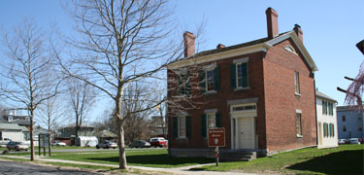
Women’s Rights National Historical Park
- Location: Park visitor center is located at 136 Fall Street, Seneca Falls.
- Fact: At this spot Elizabeth Cady Stanton and four other women invited the public to the First Woman’s Rights Convention to discuss increasing the role of women in America.
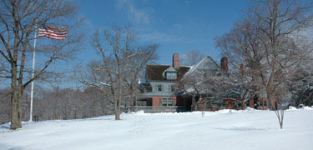
Sagamore Hill National Historic Site
- Location: 12 Sagamore Hill Road, Oyster Bay, NY 11771
- Fact: This was the home of Theodore Roosevelt, the 26th President of the United States, from 1885 until his death in 1919.

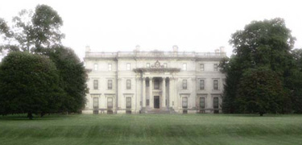
Vanderbilt Mansion National Historic Site
- Location: Hudson River Valley in Dutchess County, New York
- Fact: This site is a complete example of a gilded-age country place due to its interiors, mechanical systems, road systems, and landscape. It illustrates the political, economic, social, cultural, and demographic changes that occurred as America industrialized in the years after the Civil War.

