Badlands
- It is one of the largest protected mixed-grass prairies in the United States
- The park is home to many species of wildlife including bighorn sheep, bison, the swift fox, and the endangered black-footed ferret.
- Badlands National Park contains the world's richest deposits of fossils from the Oligocene epoch.
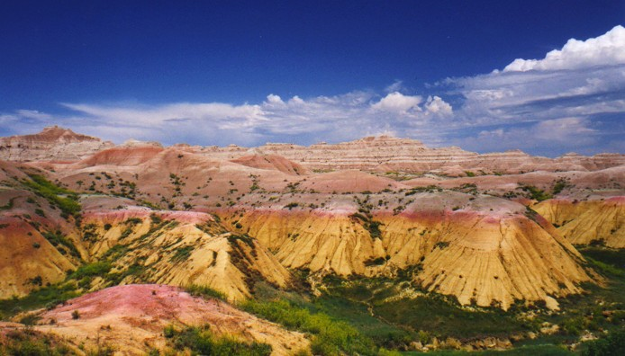

Wind Cave National Park
- The park’s mixed-grass prairie is one of the few remaining and is home to native wildlife such as bison, elk, pronghorn, mule deer, coyotes and prairie dogs.
- Over many years of exploration and mapping, Wind Cave has grown to be one of the world’s largest known caves.
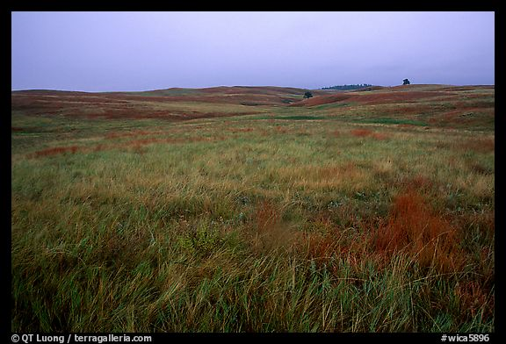
- It is the third longest cave in the U.S. and the fourth longest cave in the world.

Mount Rushmore Nation Memorial
- The four figures, George Washington, Thomas Jefferson, Abraham Lincoln, and Theodore Roosevelt, carved in stone on Mount Rushmore represent the first 150 years of American history.
- The memorial serves as home to many animals and plants representative of the Black Hills of South Dakota.
- Today millions of visitors come to see Mount Rushmore and gain inspiration from these four great men.
