Vanoise National Park

- The park was created in 1963 and was the first national park of France.
- Chamois, ibex, marmots, 125 species of birds including golden eagles, various owls, and three-toed woodpeckers, as well as an enormous array of alpine wildflowers all thrive in the valleys and peaks of Vanoise.
- It is located in the Alps in the south-east of France, near the Italian border.
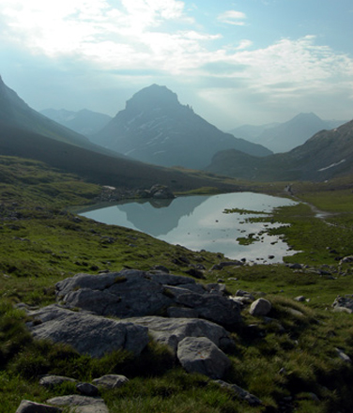

Cevennes National Park

The park was created in 1970. The Cevennes are part of the Massif Central mountain range
- It has a rich diversity of plants and wildlife including beavers, wild boar, otters and over 2,250 species of plant including the carnivorous plant the Sundew.
- The park covers a range of habitats from limestone plateaus, to deep valleys and caves to rich forests.
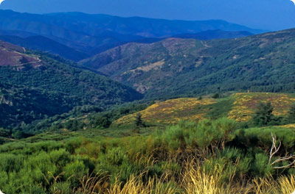

Écrins National Park
- The park was created in 1973, and is the second largest national park in France.
- There are a few small towns and villages in Écrins National Park which can usefully act as a base to explore the region.
- The aim of the park is to preserve, where possible, the cultural and architectural heritage of the different communities.
