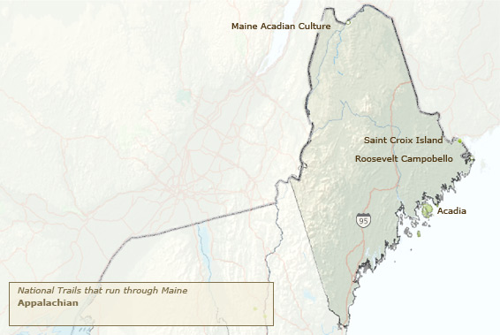
Maine
The main Acadian Culture is next to the Saint John River and happens to be directly between the equator and the North Pole.
The Saint Croix Island commemorates the 35 of 79 people from Pierre Dugua’s French expedition that died.
The Roosevelt Campobello commemorates where Franklin Roosevelt spent his summers and the cooperation between the U.S. and Canada.
Acadia National Park is known for its intense beauty, and holding the tallest mountain in the U.S. Today visitors come to Acadia National Park to hike granite peaks, bike historic roads, or to simply relax and enjoy the scenery.

