North Dakota

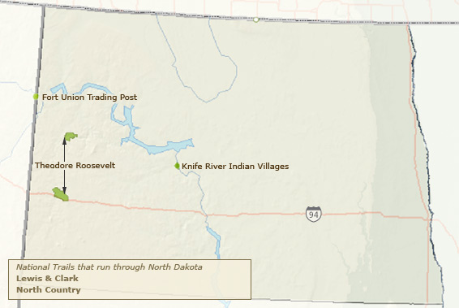

This National Park is named after
President Theodore Roosevelt because
he credited his ability to become president
on his experiences in this area.

