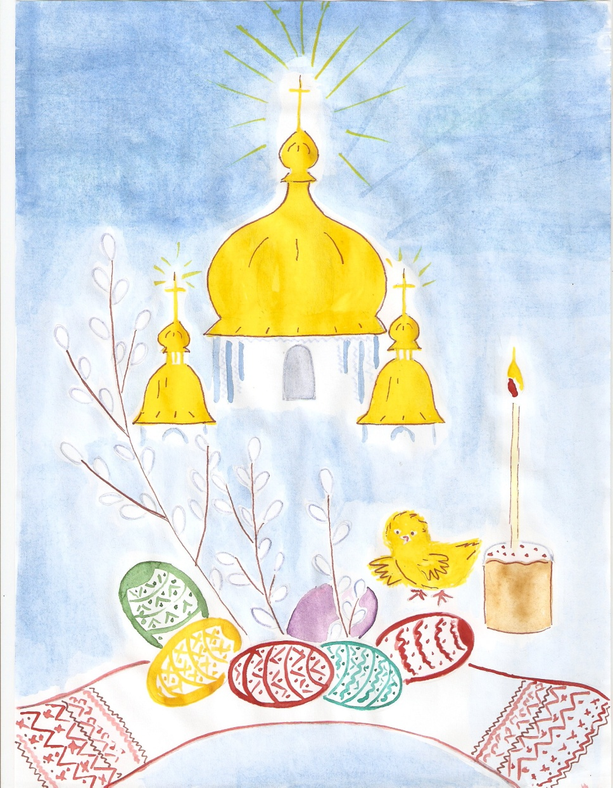

Easter, Resurrection Day,

Joy has come to us!

Those who believe are gay

To have life with Christ

Who loves everyone and me

Not to have a loss

So that he died for people

On the shameful cross

He was punished for the sins

Of the whole world

Now resurrection, brings

Life in him behold.

One of the greatest holidays of the year is Easter. Every spring all Christians celebrate the festival of awakening nature, relating the rising of the sun to the resurrection of Christ and their spiritual rebirth.

Several years ago it was proclaimed an official state holiday in Ukraine. It is celebrated between the 4-th of April and the 8-th of May. Easter in Ukraine and in other countries of the world is not always at the same time.

In our country it is the principal spring festival, its rites are closely related to agriculture, to the remembrance of dead, and to the marriage season; during their performance, praise is given, and ritual songs are sung, and there is much well-wishing. Easter is the feast of joy and gladness that unites the entire community in common celebration. People try to stay awake all night before Easter. Many people go to the church at night for the vespers, or come early the next morning to bless the food for Easter breakfast. For three days people celebrate it to the sounds of bells, and to the singing of spring songs – “vesnyanky”.

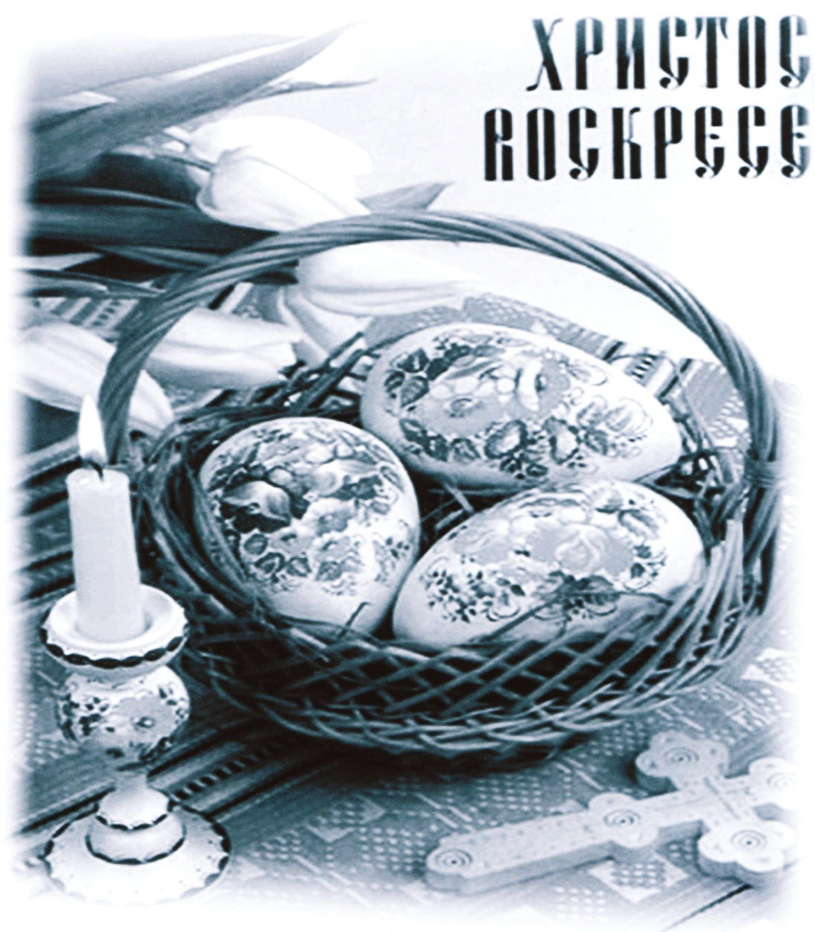

In Ukraine Easter has many rich traditions. Traditionally people bake special bread called paska and paint eggs called pysanky or krashanky.

A paschal cake (“paska”) is baked at Easter time. In different regions of Ukraine people have their traditional recipes of making Easter cakes as well as every hostess has got her personal secrets - either with soft cheese or raisins, or with vanilla or decorated.

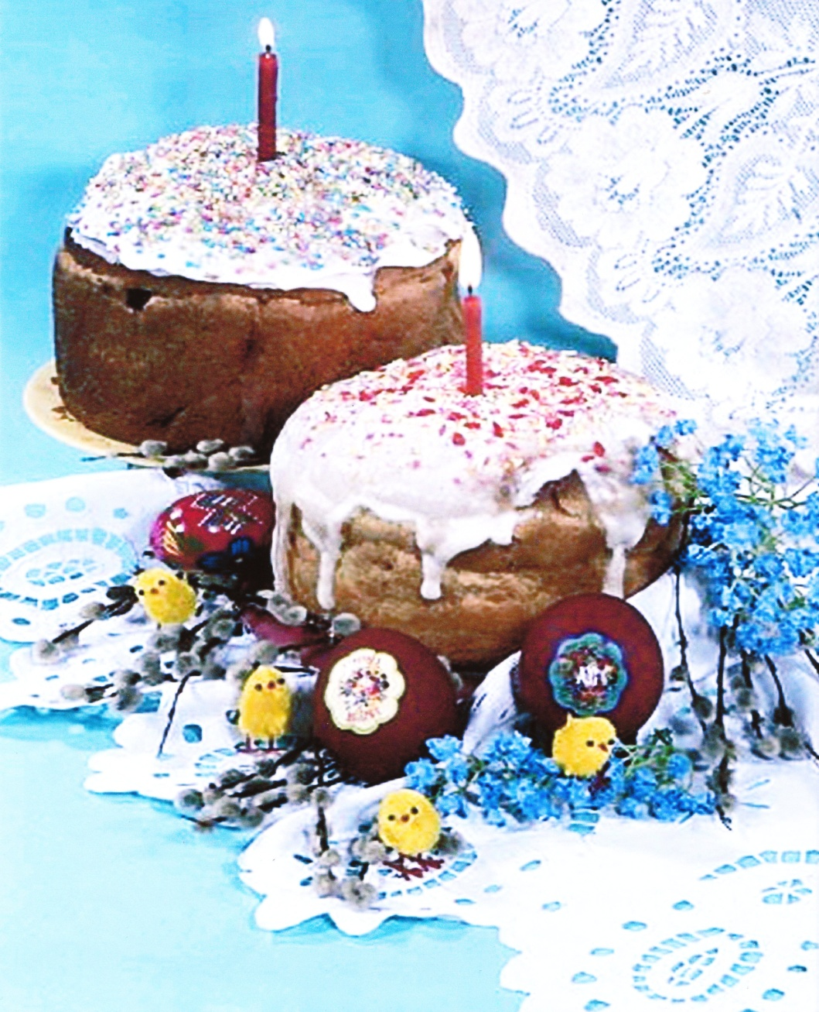

Ukrainian eggs, or pysanky, are a part of a rich history of tradition in Ukrainian culture. They are an integral part of Ukrainians` cultural heritage and ritualistic practices. Ukrainians believe that pysanky are responsible for keeping evil from taking over the world. Ukrainian “pysanky” have a symbolic significance. They symbolize spring renewed life and resurrection and have thus become associated with the celebration of Easter.

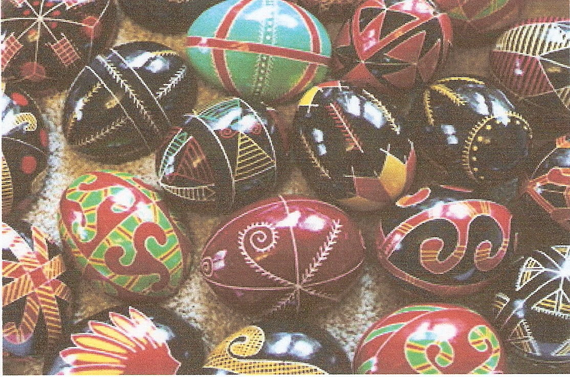

Pysanky are coloured using natural dyes from fruits, vegetables, flowers, leaves and bark. Symbols and decorations are passed from generation to generation. They can be made of various materials – poultry (usually chicken) eggs, stone, wood or clay and can be decorated by various techniques – by painting with a brush (malyovanka), by dying the egg a solid colour (krashanka), by dripping hot wax on the egg before dying it (krapanka), or by scratching a design on a dyed egg (dryapanka).

Decorating Easter eggs has been a great art for many years. Women and children paint designs with beeswax on an egg, they dye the egg. They melt away the wax after the dye has dried. When the beeswax melts away, the design is the colour of the egg. They dye the eggs with food colouring or Easter egg dye. After the eggs are dry, more decorations can be added with stickers and felt-tip pens.

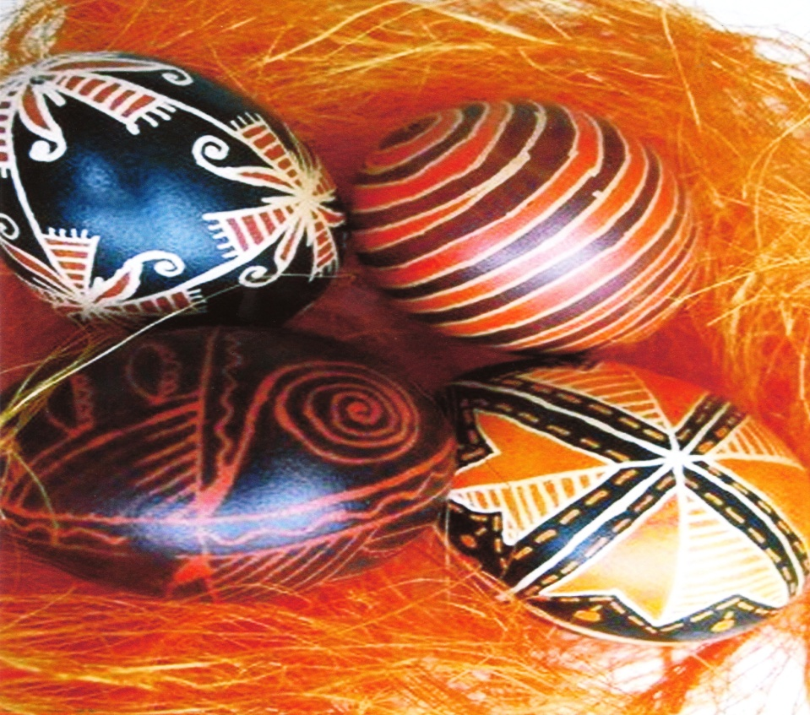

The Hutsuls – Ukrainians who live in the Carpathian Mountains of western Ukraine – believe that the fate of the world depends upon the pysanky. As long as the egg decorating custom continues, the world will exist. If for any reason, this custom is abandoned, evil – in the shape of a horrible serpent that is forever chained to a cliff – will overrun the world. Each year the serpent sends out his minions to see how many pysanky have been created. If the number is low the serpent`s chains are loosened and he is free to wander the earth causing havoc and destruction. If, on the other hand, the number of pysanky has increased, the chains are tightened and good triumphs over evil for yet another year.

Never legends blended folklore and Christian beliefs and firmly attached the egg to the Easter celebration. One legend concerns the Virgin Mary. It tells of the time Mary gave eggs to the soldiers at the cross. She entreated them to be less cruel to her son and she cried. The tears of Mary fell upon the eggs, spotting them with dots of brilliant colour.

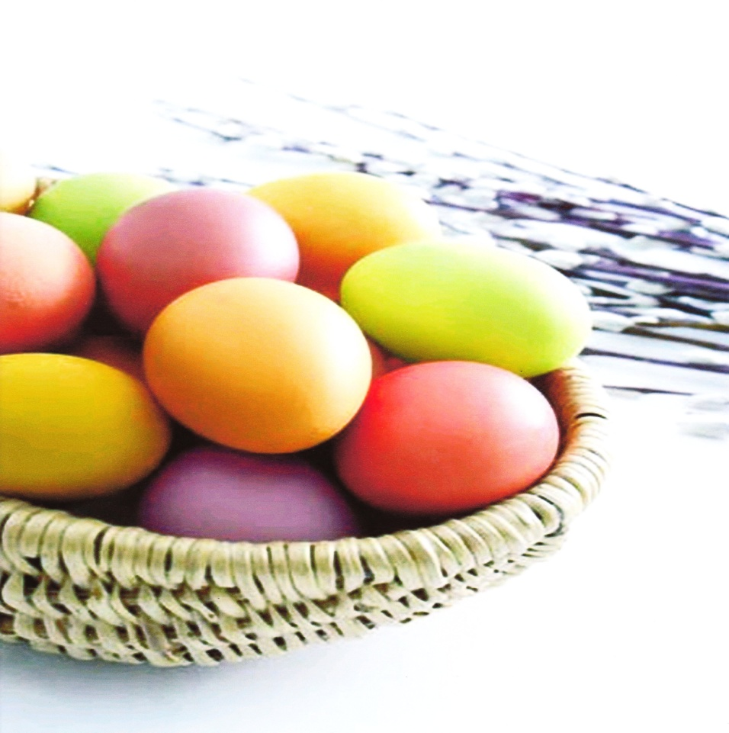

Ukrainian eggs are given to relatives, friends and respected members.They can be placed around the house for protection, arranged at the graves of loved ones, and used around family farms to promote good harvests, healthy livestock, and prosperous beehives.

People bless paska, eggs and other food in the church. Butter, lard, cheese , sausage, smoked meat and poppy seeds, millet, pepper, horseradish are also blessed.

After the service the people greet each other, give each other “krashanky” and then hurry home with their baskets of blessed food. Then the family has the holiday breakfast. It starts with a prayer and traditional Easter greeting: “Christos voskres” (Jesus is risen). The answer is “Voistenno voskres” (Truly risen). After this greeting, people kiss each other three times. This greeting is said all Sunday and for several more days if people hadn`t greeted each other since Easter.

The first part of the meal is a slice of paska. Then children play navbytky, hit their Easter eggs to see whose is stronger. The one whose egg doesn`t crack wins.

Related to the exchange of “krashanky” is the rite of sprinkling with water, which is still carried on in Western Ukraine on the second day of Easter (Wet Monday, Oblyvany Ponedilok); it`s practiced by young people splashing the girls with water. Easter Monday is also a holiday in Ukraine. All the financial institutions, offices and shops are closed on these days. During this day children visit their grandparents and godparents and bring them paska and eggs.

Easter is the centre of an entire season of the Christian year. The season begins with Lent, a 40-day period before Easter Sunday. During the lent, Christians prepare for Easter.Lent is considered a time for penance, a time to show sorrow for sins and to seek forgiveness. One way many Christians show their sorrow by fasting, which limits the kinds and amounts of food that are eaten.

At the beginning of lent most churches hold special services in the evening. Lent continues until Holy Week, which is the final week of Lent and recalls the events leading to Jesus` death and resurrection.

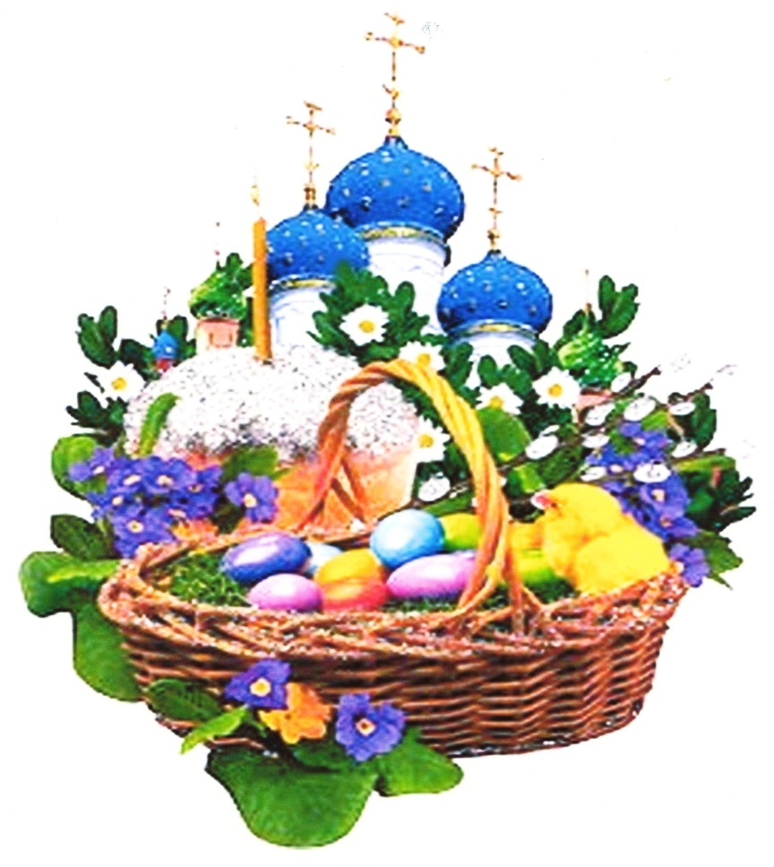

# 

Ukrainian people call Easter Velykden (The Great Day).

The last Sunday before Easter is called Verbna nedilia (Willow Sunday).

On this day people go to the church and bless pussy-willow branches there. They tap one another with these branches and say, “Be as tall as the willow, as healthy as the water and as rich as the Earth.”

People in villages also use these branches to take their cattle out to pasture for the first time. Then one of the men in the family thrusts his branch into the earth for good luck.

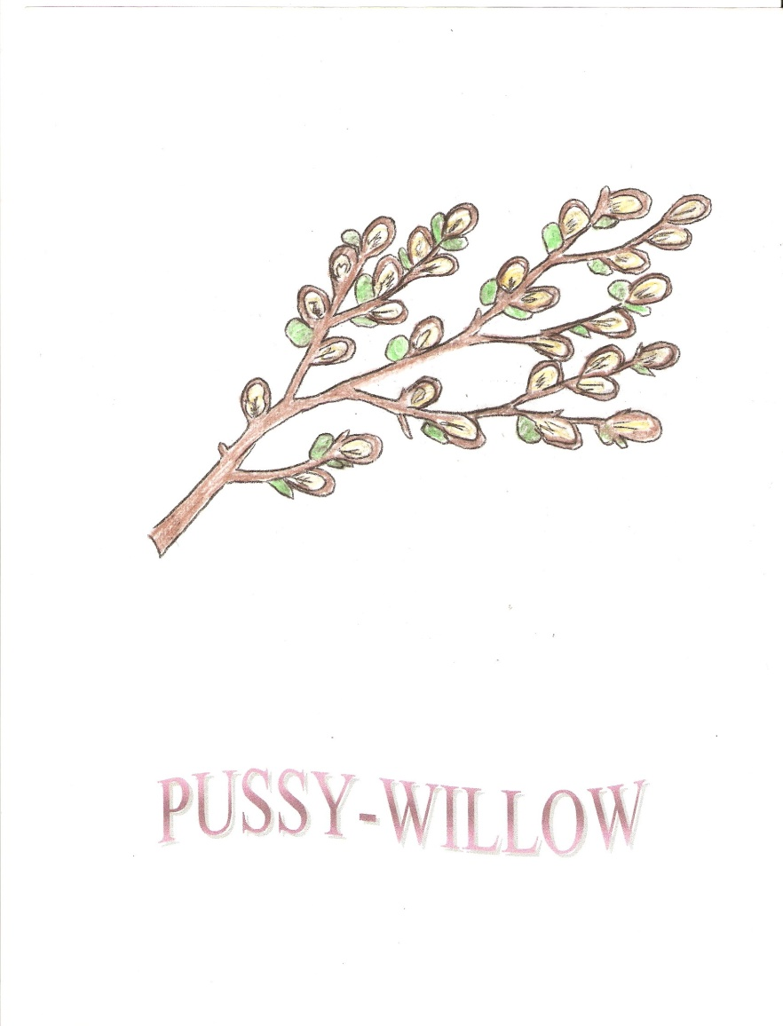

The week before Easter when preparations for the holy day are done: housecleaning, cooking, baking, making Easter eggs. By Thursday people try to finish all the fieldwork.

CLEAN THURSDAY (Chystyi chetver) is the day when people tid

y their houses and yards. It is also the main day for baking paska (Easter bread).

GOOD FRIDAY (Strasna piatnytsia) is the most solemn day of Easter because this is the day when Christians remember the Crucifixion of Christ.

HOLY SATURDAY. People try to stay awake all night before Easter. They go to church at night or come early on Sunday morning to bless the food for Easter breakfast.

EASTER SUNDAY. After Easter mass people walk home carefully not to let the candle lit in church burn out. At home families gather around the table. The holiday breakfast starts with a prayer and a traditional Easter greeting: “Khrystos voskres” (Jesus is risen). The answer is “Voistynno voskres” (Truly risen). Then families share the food blessed in church.

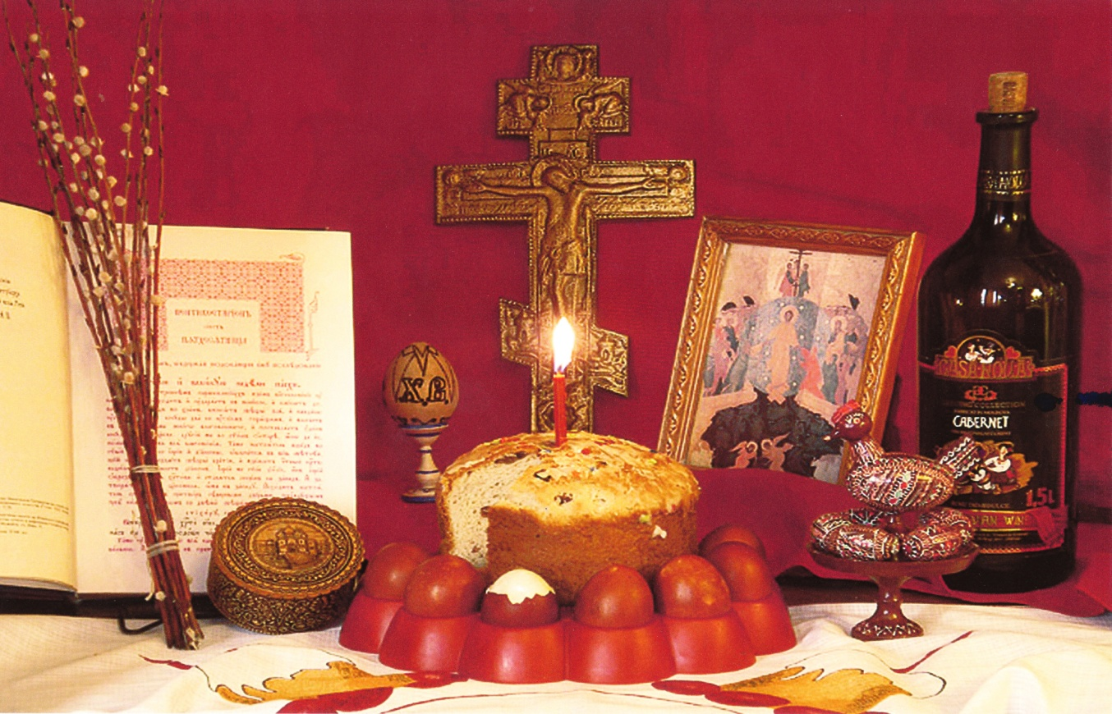

The Easter basket is the pride and joy of the family. The basket should be linen with an embroidered or white napkin. An embroidered serviette should be used to cover the basket.

Remember, the basket should contain only a sampling of the foods you are going to eat at Easter time not the entire contents of the refrigerator.

The Easter basket should contain:

PASKA – Easter bread. Place a candle into the centre of the paska and light it when the priest begins the blessing ceremony.

BABKA- Easter cake.

PYSANKY or KRASHANKY – Easter eggs.

EGGS- hard boiled.

SALT – a small amount.

BUTTER – should be nicely shaped and placed on a small dish or on top of the cheese.

CHEESE – sweet cheese. Place on a dish and on top you can place the butter.

HORSERADISH – a piece of the root or prepared horseradish with beets.

KOVBASA – homemade sausage – a small ring.

Tie a few willow branches to the handle of the basket with a red ribbon. Spring flowers can also be added.

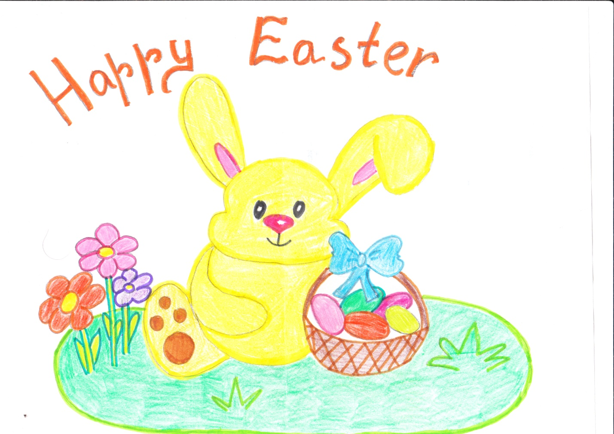

I always celebrate Easter with my family. It is a great holiday in Western and Eastern Europe. Early in the morning we go to the church and after a short mass the priest puts the carpet on the altar table. After that all the believers go around the church singing religious songs. Then we go home with our baskets to have holiday breakfast.

In the afternoon we go to the village to see my grandfather’s mother. There we sing songs, go to the river and play games with Easter eggs. After that we go home, have dinner and go to bed in a good mood.

Valentyn, class 8B

Easter is my favourite celebration. My family and I always celebrate it in the village.

My grandma tries to prepare everything till we arrive. When we come to the village we begin to prepare foe Easter celebration. My mum bakes paska and we help her with cooking. In the evening we put the foods into the basket. At night about 4 a.m. we go to church. There we bless the food.

About 6 a.m. we come back home. First we have breakfast, then we go to sleep. During the day we go to the forest, meet with our friends and eat delicious food.

On Tuesday we go to the cemetery where our relatives are buried.

In such way we celebrate Easter.

Tania, class 8B

Easter is one of my favourite holidays. Every year at Easter my family and I go to the village. On Saturday evening my mum and I cook a lot of delicious food. Traditional Easter foods in Ukraine are meat dishes, sausages, eggs, butter and many others.

On Sunday morning our family go to the church. In the afternoon we meet with our relatives and have a picnic in the forest.

I think that Easter is a family holiday. I like this holiday very much because I love my family.

Nastia, class 8B

Easter is my favourite holiday. My family and I always prepare for it.

The day before Easter my granny bakes Easter bread which is called paska and cooks many other foods. The main attribute of Easter is pysanky (Easter eggs). Every year I make them. It is very interesting. Each pysanka is made with love.

Then I prepare the Easter basket. Here must be: pysanky, *sausage, hoseradish,garlic and,* of course paska.

When we have done this we go to church. There we bless the food and then go home. I think it is a special celebration for each family.

Olha, class 8B

Easter is one of the most beautiful holidays of the year. It is celebrated in spring. The holiday’s customs are very interesting and beautiful! There are many traditions of Easter celebration in my family.

Every Friday before Easter my family and I go to the village. On Saturday we have a lot of work to do. Every member of our family has some work to do. My mother and I cook all the Easter dishes. My father and brother clean our yard and garden. In the evening all my family put much tasty food into the basket.

On Sunday morning we all go to the church.

Yaryna, class 8B

Well, Easter is one of my favourite holidays because it`s a family holiday. Every year I and my mum prepare the Easter basket.I like to paint Easter eggs in different colours. It`s very fun. We also go to the church. We go there in the morning .My dad takes the basket and I light the candle and wait till the basket is blessed. After that begins my favourite part of celebration –eating all the provisions from the basket.

There is one more reason why I like Easter, it`s because only on this day all our relatives gather together and we feel like one big family.

By Lesia, class 7B

HOW I CELEBRATE EASTER

For me Easter is a great religious holiday and the beginning of nature awakening. On that day I go to the church and listen to the service. My basket consists of :Easter eggs, Easter cakes, butter, cheese and other delicious provisions.

My family believes that Easter eggs have a magic power and can protect from evil, thunder or fire and have a healing power. In the morning after the Easter service we greet each other and return home for breakfast.

By Anastasia, class 7B

HOW I CELEBRATE EASTER

I`m the happiest person in the world as I have an opportunity to keep the family traditions every spring and see that our people believe in God resurrection. They bake Easter cakes, paint Easter eggs and greet each other and they are glad that this religious holiday unites all the Ukrainian people.

I also celebrate Easter with my family. My parents tell me about the meaning of Easter and after the celebrations we sing songs.

By Michael, class 7B

HOW I CELEBRATE EASTER

Each family has their own customs and traditions concerning Easter. It is celebrated by all believers from small children to adults and elderly people.

As for me, I always keep the lent before Easter. Go to the church and confess. I make a basket and bless it at 3 a.m. After returning home I pray, thank God and eat Easter food. Sometimes we go to the country for celebrating Easter. That`s how I spend the Easter day.

By Diana , class 7B

HOW I CELEBRATE EASTER

Easter is the busiest and the most cheerful holiday. I begin from the baking Easter cake. It is baked in the form of a cylinder and it is very delicious.

On Saturday evening I with my mum prepare basket with beautiful towel, put Easter cake ,boiled and painted eggs, sausage, salt, garlic and some sweets. On Sunday morning I put on new clothes, take my basket and go to the church. After blessing the food I return home and have breakfast with my family. Then we play my favourite game:"Knocking the eggs” ( if you knock somebody`s egg and your egg is not broken – you are the winner).

I also like the second day of Easter, when boys and girls water each other. It`s very funny. I like this holiday!

By Oleg, class 7B

HOW I CELEBRATE EASTER

I want to tell how I celebrate Easter. Two days before Easter I go to the village. I help my grandmother to bake and paint eggs into different colours: red, yellow, pink and orange. We prepare food and in the evening, put it into the basket. At 12 o`clock we go to the church. In the morning we come back home and eat the sacred food. Then I have a rest and walk with my friends.

By Ira, class 7B

HOW I CELEBRATE EASTER

Easter! This holiday is unforgivable! All people prepare to it. They tidy their rooms, wash dishes and cook.

My family prepares to this holiday too. We get together and paint eggs. There is a superstition: “When we draw eggs, we must be in a good mood”. When we draw eggs we are laughing. Afterwards we go to the church, bless food. This is the best holiday of the year.

By Julia., class 7B

HOW I CELEBRATE EASTER

I begin to celebrate Easter from the midnight of the previous day. All our family goes to the church to pray and sing songs about the Jesus Christ. But before going to the church we put different provisions into the basket. In the middle of the basket we put Easter bread and other food such as: leaf lard, smoked meat, cheese, butter, Easter eggs and a candle. In the morning, when the baskets are blessed by the priest, we go home. We sit at the table and begin to eat. By the way it is my favourite holiday because I like to get Easter eggs.

By Katia., class 7B

HOW I CELEBRATE EASTER

I always celebrate this holiday in the village with our relatives. We go to the church at night, then our friends and relatives come to our home and we spend the whole day together. That`s all about it.

By Maria , class 7B

HOW I CELEBRATE EASTER

Easter holiday. I wait for it for the whole year. It is the best Christian holiday. More than two thousand years ago Jesus Christ sacrificed his life to save the humanity. We remember about this event with sorrow and happiness. People bake Easter bread in honour of this day. There is peace and love in the whole world during Easter holidays.

By Inna, class 7B