Moon Festival
Sara Hsu, Sinjhuang Junior High School, Taipei, Taiwan

I have celebrated Moon Festival many times. We had almost the same activities every year. But what we did this Moon Festival was very special because a big typhoon is in Taiwan. So now, let me introduce this special Moon Festival to you.

In Taiwan, on Moon Festival, we'll eat the moon cakes and pomelos. The moon is big and round on Moon Festival. Some pomelos are yellow and some are green.
A pomelo is like an orange, but bigger and not that sweet. We always peer the pomelo carefully and make it become a pomelo peer hat. We always wear this kind of special hat because it keep us away from ants.

What we do this year was barbecuing. But it's rainy, we sat a big umbrella up
so we wouldn't get wet. It was a happy dinner gathering and a very nice day.
I hope there won't be any typhoon on Moon Festival, so I could see the beautiful moon.

Moon Cakes
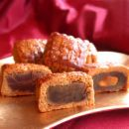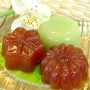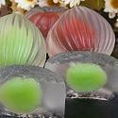

Pomelo Hates
