The story of Moon Festival
Arial Tsai , Sinjhuang Junior High, Taipei
Long time ago, there was a cruel emperor whose name was Hou Yi. He had a beautiful wife named Chang’e. Hou Yi wanted to be immortal, so he was looking for the elixir that could let him become deathless.

One day, he found the elixir which he wanted. Although there were only two pills, he was still very happy. “These are the pills. One is for you, and the other is for me. After we eat them, we will be immortal” Hou Yi told his wife. But Chang’e was not happy. Actually, she was worried about the populace because Hou Yi was not a good emperor.

After she thought for a long time, she decided to steal the pills and eat both of them. So she ate both of the pills. Then, something strange happened. She became lighter and lighter. Finally, she flew to the moon and disappeared. And this is the story of the moon festival.
 ←Chang’e
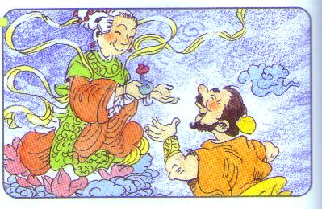←Hou Yi

