Moon festival
Miffy Chen, Sinjhuang Junior High, Taiwan

Well , there are many festivals in Taiwan, like Dragon Boat Festival, National Day or Double Ninth Festival . But I think the most interesting festival is Moon Festival. It has many special stories.

One of the stories goes, long time ago, there were 10 suns in the sky. The plants were burning and the people were very thirsty and almost dying. However, in the village, a hero named Hou-Yi, used his bow and the arrows to shot down 9 suns. He was brave. Because Hou Yi saved the villagers’ life, they respected him very much..

Hou-Yi married a beautiful wife, named Chang- E. Someone said that Chang-e stole Hou Yi ‘s medicine that can let people never die .But my friend also said when Hou Yi became a hero, he was more and more arrogant. Chang-e was sad ,so she took the medicine, left her husband and flew to the moon.

This is the story about moon festival from our traditional culture. It’s just a fairy tale. Maybe it was true or it was only a fake. No one knows.
Do you believe it or not?

Full Moon Chang- E flew to the moon
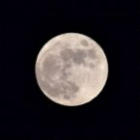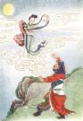

Hou-Yi was shooting the sun
