Linda Lin, Sin-Jhuang Junior High, Taipei, Taiwan
The Lantern Festival is celebrated on the 15th day of the first month of the Chinese year. Every year you can see many colorful lanterns at Chiang Kai-shek Memorial Hall. How did this begin? A long time ago, people said that spirits flew in the light of the first full moon of the year. In the past, people used torches to see them.
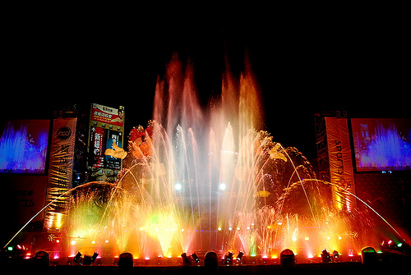
Like many other Chinese festivals, this festival has a special food, called “Yuan Shiao” which symbolizes the reunion of the family. Also, many people still believe that they do not gain their one year in age until they eat their “Yuan Shiao. =)
