Our schoolsystem

We’re one school with 3 parts in 3 different buildings.
The first part is the boyschool, the second is the girlschool and the thirth is a school *with mixed gender.
Our school is the girlschool.
We go to school 5 days a week, from Monday to Friday. On Wednesday we have the afternoon off. The first lesson in the mornings starts at 7:25 and the last lesson ends at 17:25.
Our schoolsystem in Switzerland starts with the Kindergarten. After two years there we go to primaryschool, there we learn about six years reading, writing and *calculating. Then we can go to secondaryschool or a “realschool” for three years.
The realschool is a school where are students who aren’t very good at school, they learn the same subjects, but not as quickly as we do.
The secondaryschool subjects are:

→ German
→ French
→ English
→ Maths
→ Nature and technology
→ Spaces and times
→ Sports
→ Domestic scince
→ Religion

At the moment we’re in the thirth year at secondaryschool. After these three years you can go to a grammarschool or you can make an apprenticeship.
*give information to the links

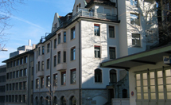
These are schoollinks from our different schools.

http://meitleflade.ch/cms/typo3/index.php?id=9

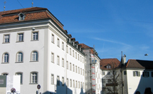

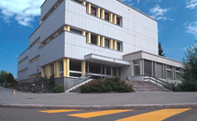
http://www.flade.ch/cms/index.php?id=10

http://www.flade.ch/cms/index.php?id=8

