

The Indian Heights School ~ E Newsletter
November was as Celebrated Water Awareness Month.
School conducted following Activities
- Drip Irrigation
- A Drop of Water
- Water Bulletin
- Every Drop Counts!
- Cushion of Nature
- Mini Water Cycle
- We are presently Working on walls with a Message

Some Tips We learnt
- There are a number of ways to save water, and they all start with all of us
- Wash your fruits and vegetables in a pan of water instead of running water from the tap.
- Use drip irrigation for shrubs and trees to apply water directly to the roots where it's needed.
- Water your lawn and garden in the morning or evening when temperatures are cooler to minimize evaporation.

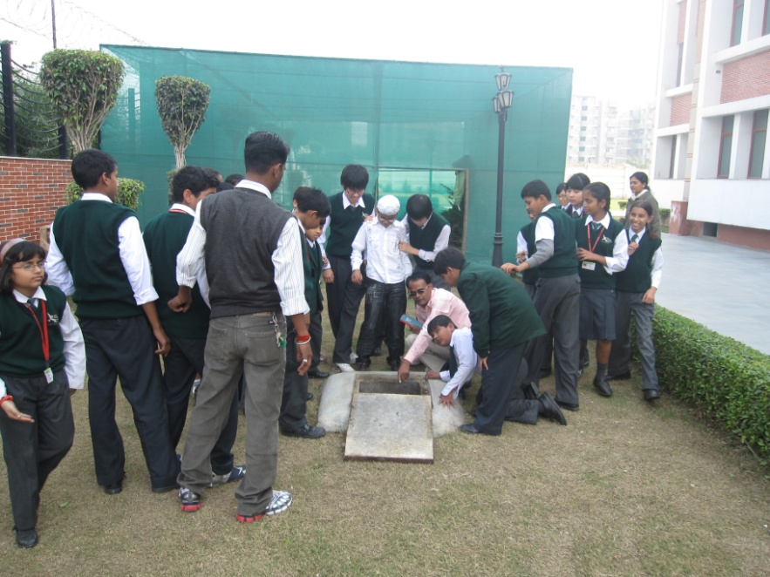
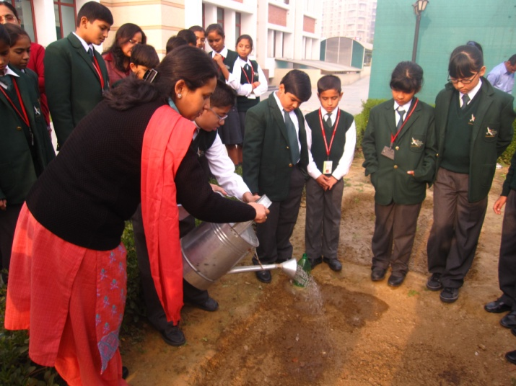

Message for All
Let’s join Hands to save and recycle water. Remember Every Drop Counts!
SAVE THE BLUE PEARL
Did you know that every drop of water that runs down the drain ends up flowing into the sewage system? Sending clean water down the drain fills up the sewer and lets dirty water and waste overflow into the streams and oceans. Polluted water can harm, and even kill, animals that drink it and live in it.

Ms. Suchita conducting the Drip Irrigation activity
Students looking at Rain Water Harvesting tank in the school.

