PROJECT TIGER


Under the guidance of Mrs. Narain, the students of VIII B (2008-09) held a campaign for the protection of Tigers, our national animal and an endangered species.

The students collected donations for the same. Different articles like mugs with photographs of tiger and their claws, tablecloths, posters and many things were prepared by the students. These articles were sold and money was collected for donation purpose.

The students of HVB were made aware of the conditions of tigers by means of collecting and reading newspaper articles related to tigers. More information related to this project was collected from the internet and shared among students.

Forms were distributed to join the campaign to teachers and students.

There was an overwhelming response from everyone at HVB and this campaign was supported whole heartedly.

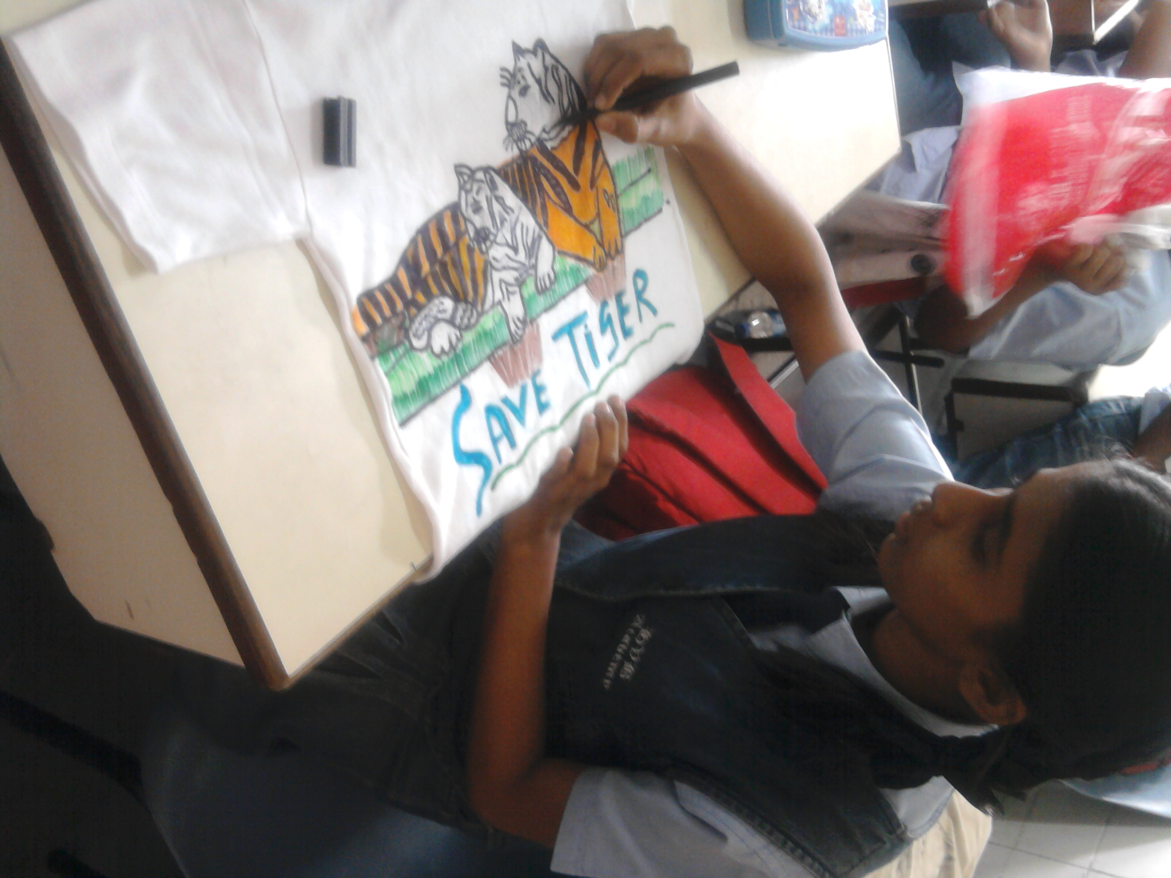
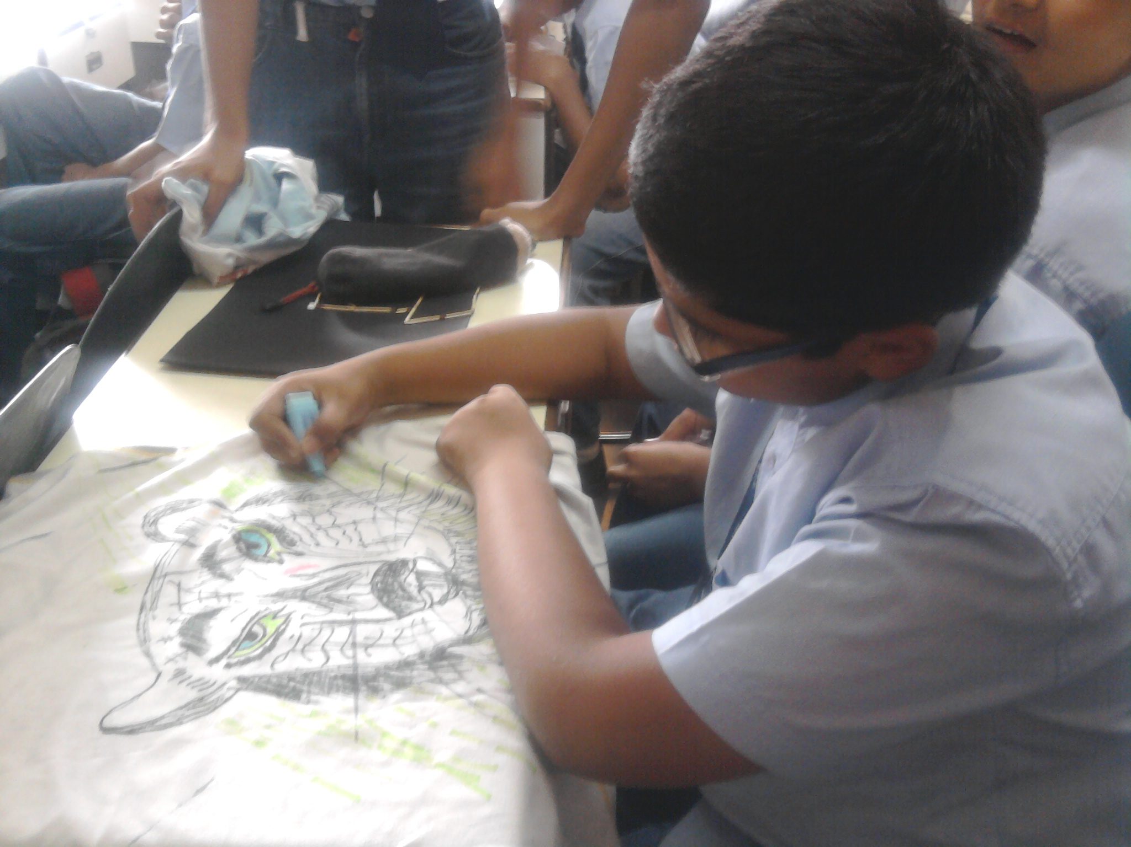

Students of IX C painting tiger and slogan ‘Save Tiger’ on T-shirts in the SUPW period.

