Crossword
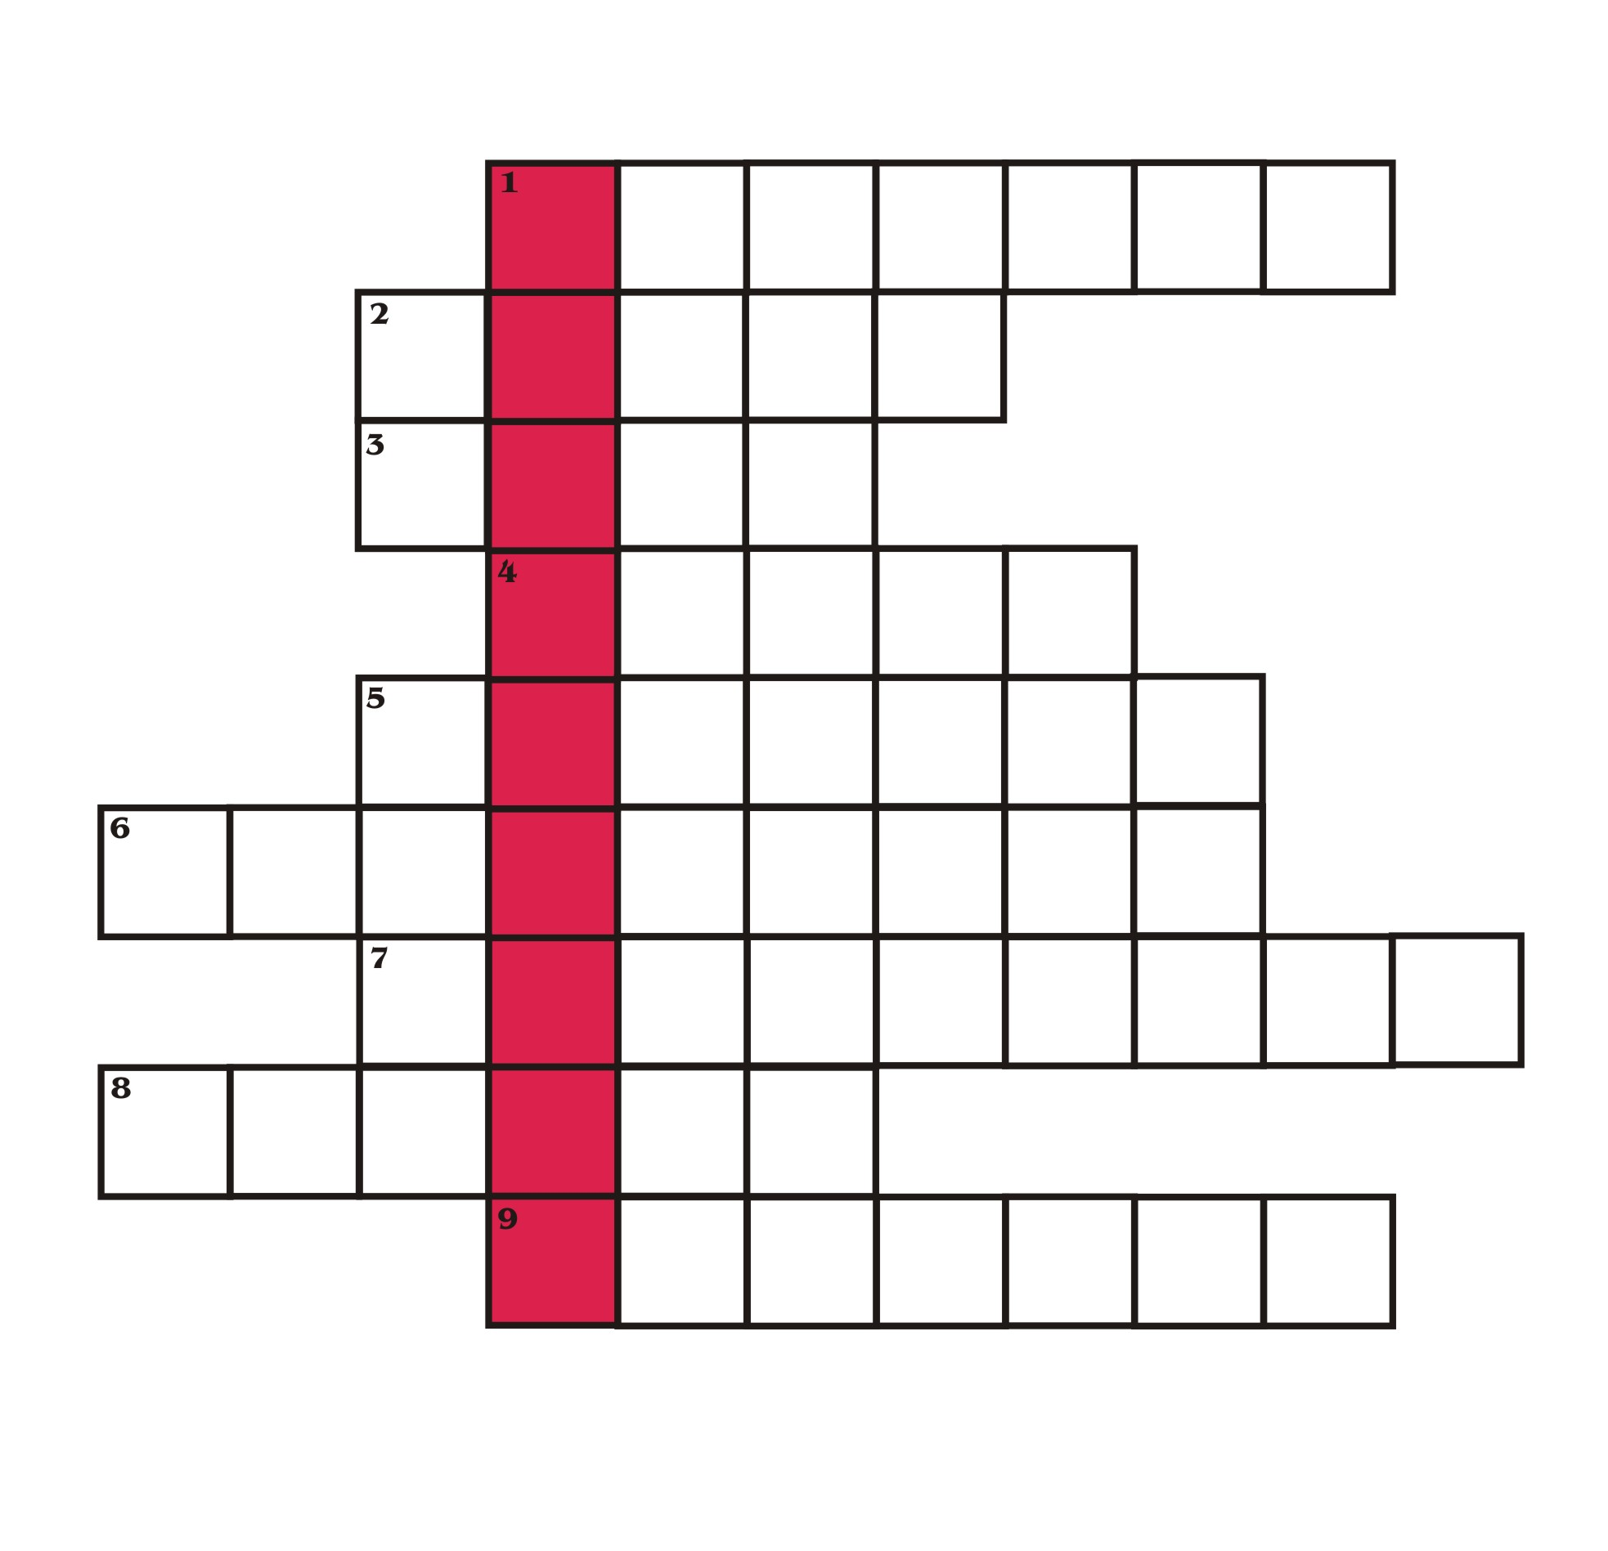

1. Biomaterial
2. Regular movements of the sea
3. Solid fuel
4. Related to the Sun
5. Endangered …………….
6. Houses built from ecomaterials
7. Energy that is never completely used up
8. Synonym of spring – place or thing that provides something
9. Animals or plants that don’t exist anymore

CROSSWORD
ANSWERS

