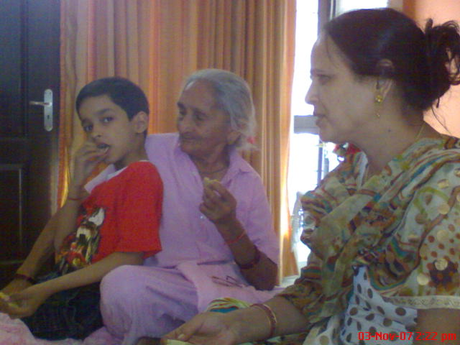

Grandparents are everything for us

If anyone asks us who is of great value to you in your family I would certainly say that my grandparents are of real worth to me. They give us something valuable and that’s their selfless love and blessings. In their lap we are carefree and even forget our parents. I feel that in old age our grandparents need our care and affection. Our parents are careworn and busy in chores so it’s our moral duty to show our grandparents that we really need them. They are a part of our life and they should not feel alone at all.

I live away from my grandparents but in vacations i visit my grandparents and take some gifts for them. To tell you the reality they need our physical presence not our gifts. Whenever I am in any kind of difficulty I prefer to take advice of my grandmother rather than my parents as she understands me well and has a sympathetic attitude towards me. My mother loses her patience soon so I am a bit hesitant to approach her.

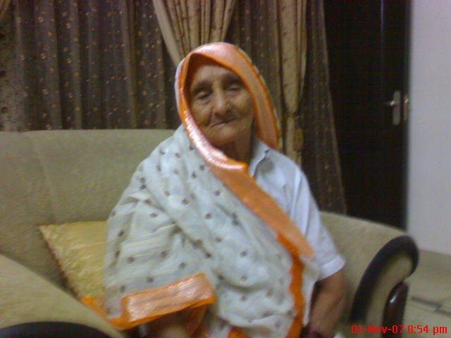

I often see my grandmother’s photo and remember her. I have no brother or sister so I feel alone and share all my worries and little joys with my grandparents. After all they are more reliable than anyone else. I can see their anxieties and loneliness so I care for them.