They need us

Do you know the old persons are similar to little children? They become sentimental and obstinate. As little children should be looked after they also need our proper love and care. I have seen a lot of old persons being ill- treated and I feel really bad. In my village it is not so. In villages and small towns people even now care for them. In my village if any son disgraces his parents he is scolded and taken to task. So no one dares to insult his parents. All elders gather and he is criticizes publically.



When our grandparents were young they took care of our parents and fulfilled all their wishes and now they should be looked after. I see grandparents of my fellows visiting them in hostels on Sundays. I feel so good. They sit beside their grandchildren and bless them. They bring a lot of things for them. Some are poor and don’t have vehicles so they walk the distance of 2 kms and it’s quite difficult in this old age.

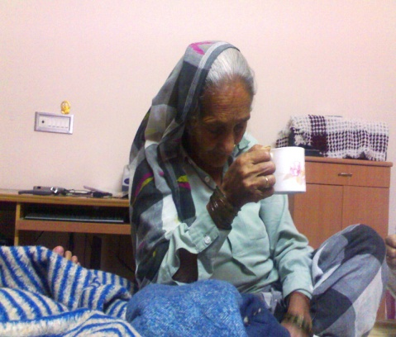

The old people become reserved and are scared of their own children but they readily share their feelings with their grandchildren as they are close to them. Their love is genuine and they care more than our own parents. I use to sit beside old persons and listen to their grudges and thoughts. I feel that they possess worldly wisdom and can give right direction to us. My friend’s grandpa is my guide. I share all my anguishes with him and wait eagerly for him every Sunday. I urge all children to compensate for the negligence of our parents and devote a little time in company of our grandparents.