THE CITY OF JOY
KOLKATA AND DURGA PUJA

A PRESENTATION

BY

ARATRIKA DAS, VIII-B

GAIL DAV PUBLIC SCHOOL
Durga Puja in West Bengal

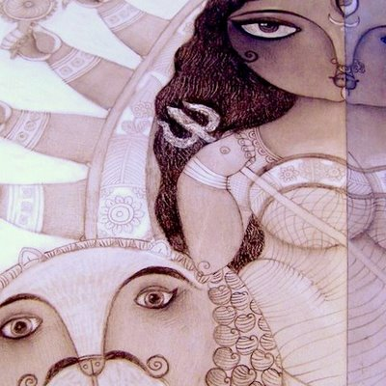

Bengal was once upon a time united. Later on, approximately two-thirds of it became a new country which we know as Bangladesh. The rest of this area which falls to the west became a state of India and came to be known as West Bengal whose main language is Bangla or Bengali as is popularly known. It is a land of rivers and green rice fields, of writers and poets like Rabindranath Tagore, Michael Madhusudan Dutta, Bankim Chandra Chatterjee and hundreds more, of film-makers like Satyajit Ray and Mrinal Sen. It is the land of hundreds of people who come from all parts of the country to earn a living, the land of Udayshankar and Ravishankar, a land steeped in history, culture and tradition, the land of the hilsa fish and himsagar mango, the land of the Sundarbans and its majestic Royal Bengal Tigers. At the epicenter of all these is its capital, Kolkata, and, at the epicenter of the lives and the festivities of its people is the Durga Puja.

The Durga Puja usually takes place in the season of autumn when the weather has cooled down a little, the skies are clear and the nature all around is very pleasant to the eye. Every Bengali soul waits all throughout the year for the arrival of this festival. The festival goes on for five days and it is celebrated amidst great pomp and show. It is a religious festival and the rituals and the worship are performed meticulously with faith and devotion. But it is also a celebration of a daughter’s home-coming. Therefore, a lot of new clothes for all members of the family are in circulation, lots of new recipes and sweet meats are prepared, a lot of annual family get-togethers are organized, and all young and old unite for a short period of festivity. We might also add that tourists from all over the world who love to participate in festivals also visit this state during this festival.

In this project, we, Aratrika Das and Avinandan Ganguly are trying to make you acquainted with one of the biggest festivals of West Bengal, India. The Victoria Memorial of Kolkata is beautiful. The Science City, the Birla Planetarium, the Race Course, the Howrah Bridge, the tramcars, the Maidan, the Ganga river that flows by this city are beautiful. The large luminous eyes of a Bengali girl and the Jamdani, Kaantha and Baluchari sarees that she drapes herself with are beautiful. The craze amongst the people of this state for a match of cricket or a game of football is beautiful. Equally beautiful is this festival of Durga puja and the love and yearning that every Bengali nurtures in his or her heart for it.

In this project we will discuss the mythological, religious, social, cultural and other aspects of this festival. We will discuss how the festival is looked upon by the people of other regions of this country before we return to West Bengal to show you why and how it is such a loved and pampered festival of this state. For a Bengali it is not only Durga Puja or Durga Worship, but also Durgotsav or Sharodotsav. We will also include some picture slides for you to get a taste of the yearly occurrence to some extent. We hope you enjoy the journey as much as we will enjoy guiding you through it. 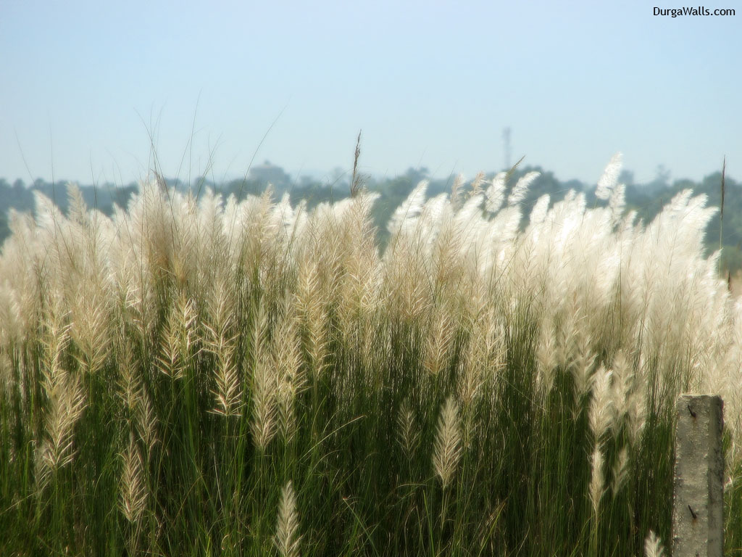
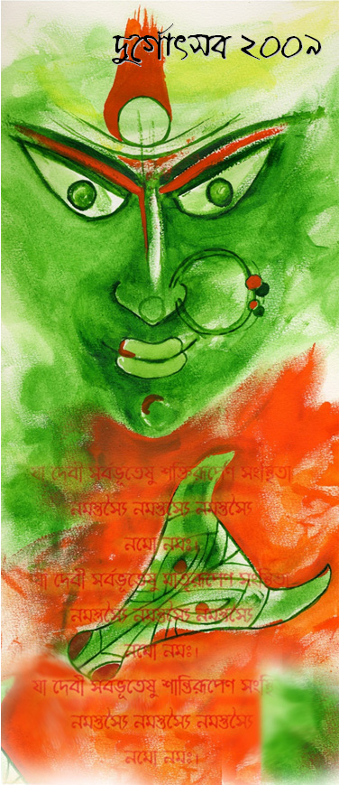

Ya devi sarva bhutesu shaktirupena sangsthita
Namastasyay namastasyay namastasyay namo namaha

Ya devi sarva bhutesu matrirupena sangsthita
Namastasyay namastasyay namastasyay namo namaha

Ya devi sarva bhutesu shantirupena sangsthita
Namastasyay namastasyay namastasyay namo namaha
Tradition of Durga Puja

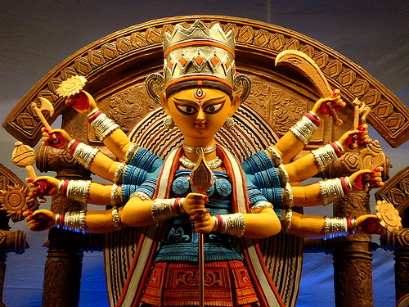

Creation of the idols
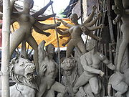

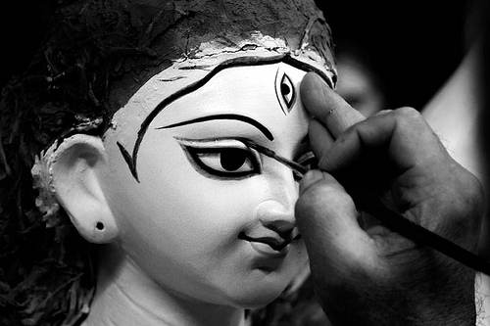

Theme-based Pujas and pandals
Pandals and idols inspired by a particular theme have been the hallmark of many community or Sarbajanin Pujas in Calcutta since the 1990s. Puja committees decide on a particular theme, whose elements are incorporated into the pandal and the idols. Popular themes include ancient civilizations like the Egyptians or Incas. Contemporary subjects like the RMS Titanic and Harry Potter have also been the subject in some pandals.
The design and decoration is usually done by art and architecture students based in the city. The budget required for such theme-based pujas is often higher than traditional pujas. They attract crowds and are well-received. Inspired by Calcutta, theme-based pandals are becoming popular in cities in neighbouring states, particularly Orissa. Experimentation with the idols does not happen much outside Calcutta.
Here we would like to show you some picture slides on puja pandals in Kolkata and their decorations. The pandals are mainly erected on frames built with bamboo and cloth.The decorations are usually done

with paper, plaster of paris,cloth, paint. But modern pandal decorations are also done with other items like shells, thermocols,plastic etc..
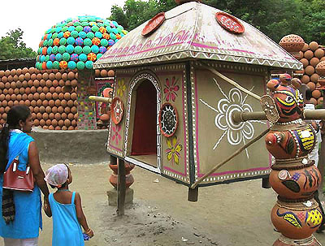

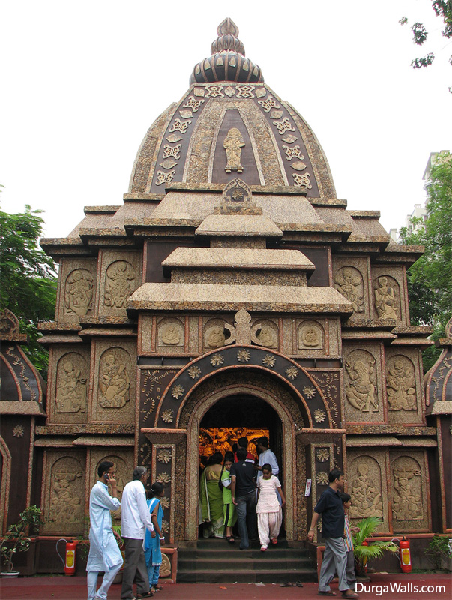

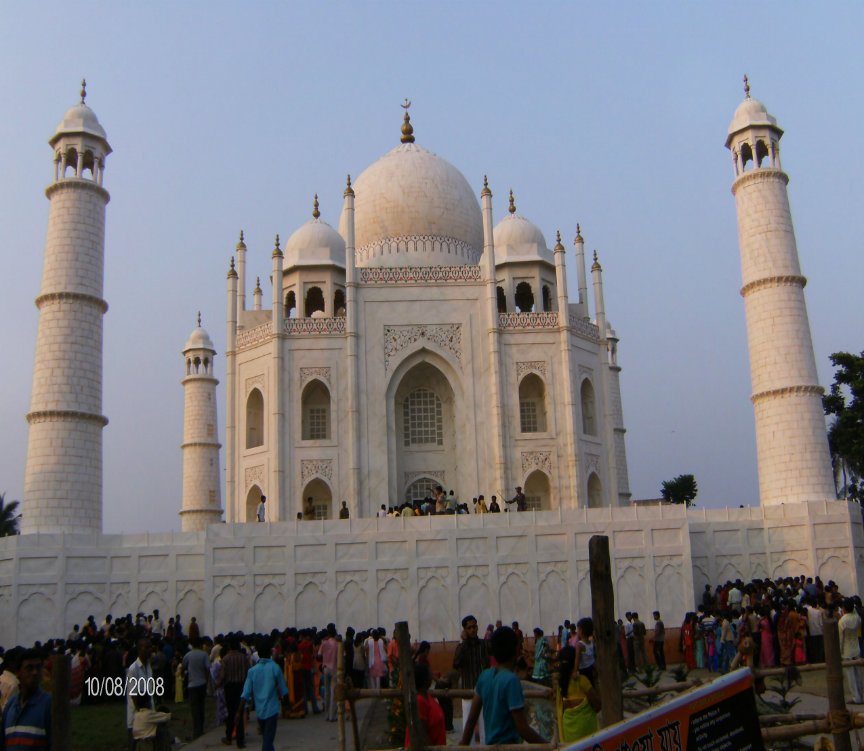

Watch carefully my friends. Do not mistake it for the Taj Mahal. It is a replica of the Taj Mahal made out of white cloth, paper and paint and used as a pandal in Palta, on the outskirts of Kolkata in the year 2008.

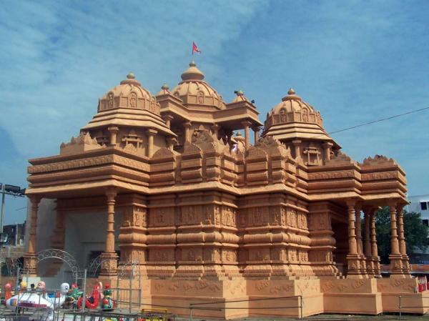

This is also not any temple made of red sandstone, but a pandal erected with the same kind of materials mentioned earlier. Let us show a few more pictures which will equally fascinate you and you will wonder at the skill of the artisans.

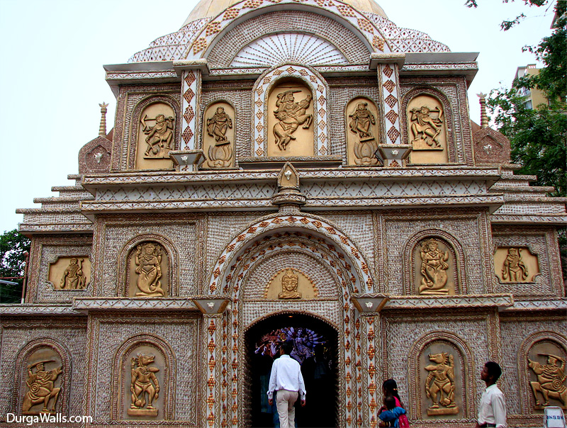

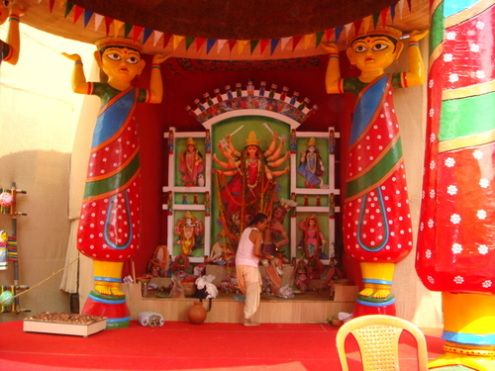

.

Durga Puja begins with Mahalaya

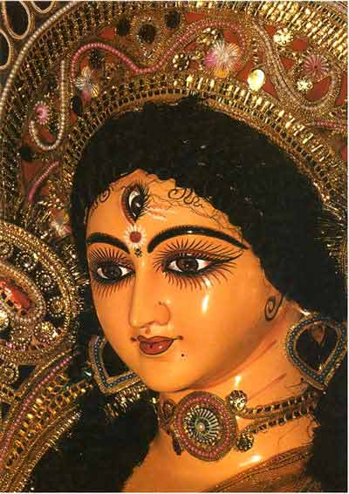

Kolkata: The six-day long Durga Puja festivities begin with Mahalaya. The people of West Bengal and other parts of the country gear up to welcome the Goddess Durga. Mahalaya is the occasion when Bengalis welcome Goddess Mahisasura Mardini into their homes. On this occasion, people take a holy dip in the river Ganga and perform ritual called Torpon. The Eyes of Durga idols and others are painted on Mahalaya. The All India Radio and Doordarshan air the invocation of the Goddess Durga. Actually it describes the story of fight between demon Mahisasura and Goddess Durga. Mahalaya also marks the beginning of Navratra in other parts of the country. A day after Mahalaya is the first day of Navratri.

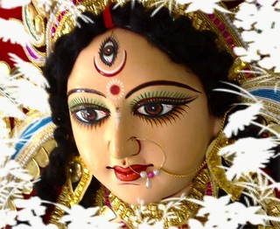

Durga Puja: A Daughter Comes Visiting

Legend has it that the powerful demon Mahisasura once placated the gods through severe penances. When the pleased gods offered him a boon, he sought immortality. This request being denied, he thought up a clever ploy and asked for a boon whereby only a woman could slay him in battle. He thought that a woman would never be able to match his physical prowess, and therefore, for all practical purposes he would become immortal anyway. Thus empowered, Mahisasura began wreaking havoc on heaven and earth.
Defeated in battle, the gods combined their divine energies and created Shakti (the primordial, cosmic, feminine energy), a goddess with varied manifestations, one of which was Durga. Armed with weapons given to her by the gods, Durga rode off into battle, mounted on a lion. A long and fierce battle ensued in which the demon Mahisasura was finally slain. The Goddess Durga is therefore celebrated as “Mahisasura-mardini” (the slayer of Mahisasura). She is the Mother Goddess, the supreme power that vanquishes all evil forces.
Initially, this Hindu festival in India was celebrated in the spring. However, today, the autumnal celebrations far outweigh the original puja of the Devi. The autumnal celebration, according to the epic “Ramayana“, started when Ram paid obeisance to the Goddess before he went into battle with the demon king Ravana to rescue his wife Sita, who had been abducted by Ravana. Since this was an untimely invocation of the Goddess, the Durga Puja conducted by Ram is also termed as “akalbodhan” (out of turn/ untimely worship).
Following the example of Ram, the Durga Puja currently is held for anywhere between 5 days (Durga Puja)-10 days (Navaratri - where 9 forms of Shakti are venerated) across different states in India.
While the basic tale behind the Durga Puja remains the same, the Bengalis have a slightly more personalized approach to the Pujas (or ‘Pujo' as it is pronounced in Bengali). It is believed that Durga is the daughter of Bengal and during these 5 days she visits her parental home along with her 4 children (Ganesh, Lakshmi, Saraswati, and Kartikeya) and 2 close friends. Interestingly, her husband Shiva does not usually accompany her on this trip. He stays behind, letting his wife and children visit Earth and enjoy all the pampering from their Bengali relatives.
.
Apart from the pandals and idols, there were the decorative lights that gave the city its glitter by night. Thousands of people poured out of their homes to celebrate the days and nights with food, drinks and ‘pandal-hopping' (visiting one puja after another).
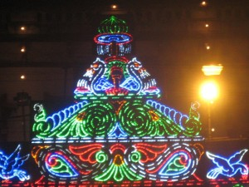
Decorative lights at a puja pandal gate.
And of course, many of the lights also carried a message, be it social or environmental in nature.
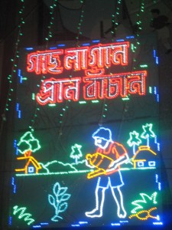
Save Life on Earth - plant a tree. The 5 days of festivities ended with Dashami, the day of immersion. This is the day when the Goddess returns to her marital home in the Himalayas. But not before the married women give her and her family a warm send-off with gifts, sweets and lots of vermilion for a long and happy conjugal life.
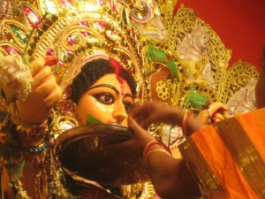
Bidding her farewell until next year.
This is followed by 'shidoor khela' (the vermilion ceremony) a ritual by married women where they smear sindoor (traditionally, sindoor/ vermilion on the forehead

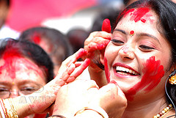
Finally, all the idols are taken to the lakes/ rivers for immersion. The pandal is dismantled and life goes on as usual, with the Bengalis beginning their wait for the year to come. After immersion, it is time again to meet and greet friends, family, relatives and all other near and dear ones as it is Vijaya Dashami, the celebration that coincides with Dussehra, the victory of Ram over Ravana.
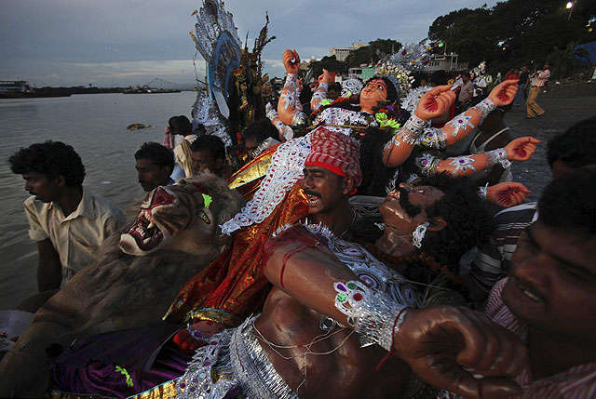

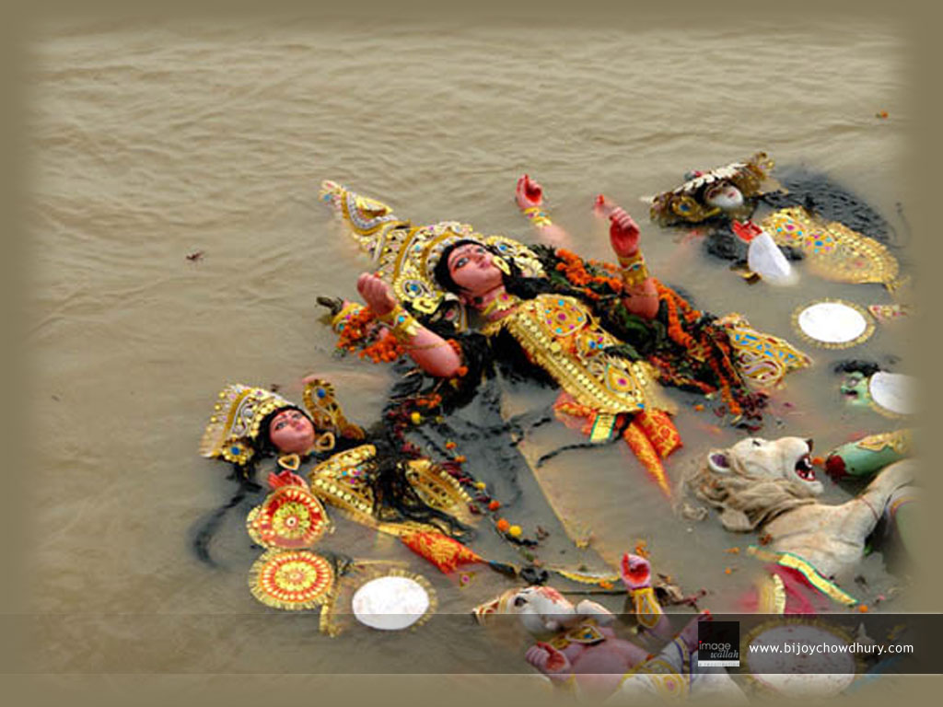

We would now like to give you and your families best wishes for the rest of the year. May the Mother bless all of you and all your loved ones. May you be successful in all that you do.

The Ganga still flows on its way waiting for the Mother to return next year. The Bengali soul waits and starts planning for the next year when the Goddess Mother and the Daughter of the house will come home to enliven them all again.
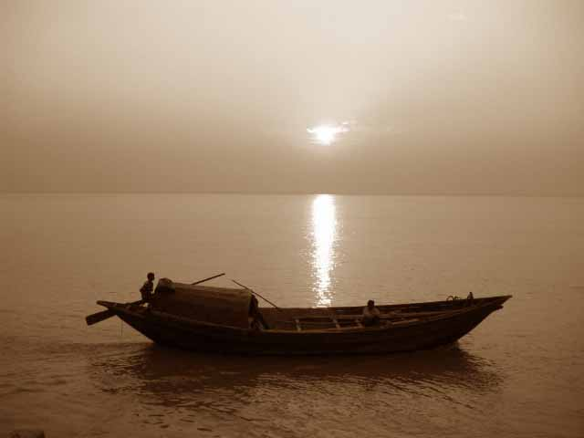

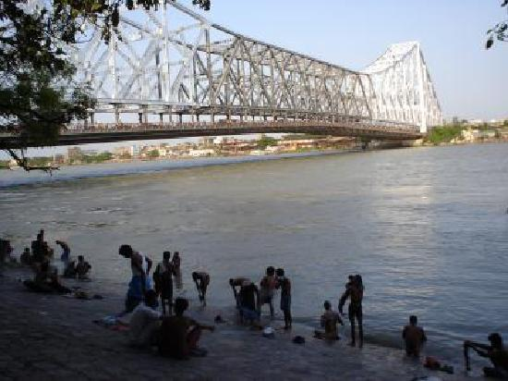

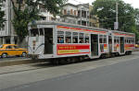

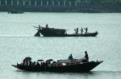

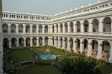

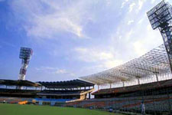

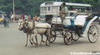

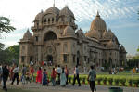
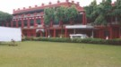

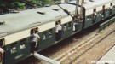
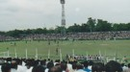

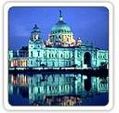

.

REFERENCES: INTERNET

