The problems of indiscipline in classrooms.

Problems in general Our school is a residential school and here we teachers have to stay for 24 hours in campus with our students. The total strength of the students had crossed 500. Nearly 300 boys up to secondary level study here and about 200 girls are there in girls’ hostels. As the teachers are 24 hours with them the students have become quite familiar to them. This closeness has given way to many problems also. The boys and girls cause many disturbances sometimes.

The one word “excuse me” has become the cause of these problems. Think of a teacher who has no personal life. He or she may tend to be irritated due to such disturbances. The whole day long the teacher has to stay with them in school and when he or she returns to flat to have a little rest or food a student or perhaps many may come to knock the door. “Excuse me Sir, Madam. I want leave to go home.” This very sentence gives headache to all the teachers! In our institution the teachers have to do many duties besides teaching. They have to look after 40 students of a house of whose he is a House master. A single girls house may have near about 100 girls and a single lady is the House Mistress. At home it is problematic to look after a girl but here there are 100 to be looked after. Everyday a few may fall ill and has to be sent home or looked after. Often the excuses are false. That’s why many of the lady teachers quit this job. Although a matron has been kept to look after the girls but the whole responsibility is of the concerned House Mistress. Even in case of any mishappening she may lose the job. Three times the teacher has to go to mess with the students. Then there are study hours in afternoons and evening and even during night time for Board classes.

Problems in classrooms- Like day schools a subject teacher has to take 6-7 periods a day and if another teacher is absent all the periods are arranged. The tired teachers who could not rest in peace even in night have to work incessantly. The children are so energetic that they are ever active and buoyant. If a teacher has denied giving leave to a student he or she is in look for an opportunity to remind the teacher the injustice done to him! Here teachers are in duty for 24 hours.

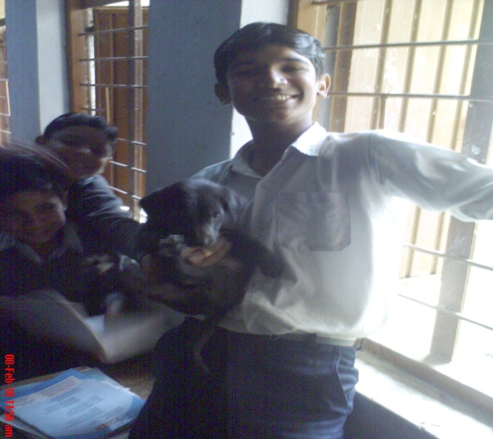

But despite this hard life the teachers have learnt to adjust in this kind of life. Some of our teachers are excellent tutors of their respective subjects. They can barely sleep more than 3-4 hours a day and still ever ready to perform their duties with vigour. This is a way of life they have adopted.

The instances of indiscipline- There are ample opportunities for our energetic students to do mischievous acts as they are here for 24 hours. A teacher has to be quite alert all day. During roll call at night the presence of all students’ is ensured by doing head counting. Sometimes a student of junior class may be found missing if he is not properly adjusted in hostel. The pupils are natives of nearby villages or town so it is quite easier for them to escape. This problem can arise when a student is new. Often the classes may be a bit noisy if teachers have to attend staff meeting. Here the praiseworthy thing is that the students have become independent and help teachers to control other students. House Prefects ease the work of House Masters and House Mistresses. The class monitors helps the class teachers in class attendance or result’s preparation. This assignment of responsibility to students makes them more sincere. They can understand the difficulties faced by their teachers. The entire House system runs thus or it will shatter.

In classrooms generally the students are well behaved. Some of the boys are unruly but they are controlled by tacts. Corporal punishment has been banned in schools so other ways are followed like counseling. For us our students are like our children as we brought them up in our tender care. We are their parents, counsellors, friends, guides, nurse everything. All students have an informal attitude towards teachers, they share their feelings, joys, sorrows everything. All the activities held in school shorten their distances. Our school is more of a large family rather than a common school.