These are scenes from Denmark.

The sea is stained red and it’s not because of the climate effects of nature.

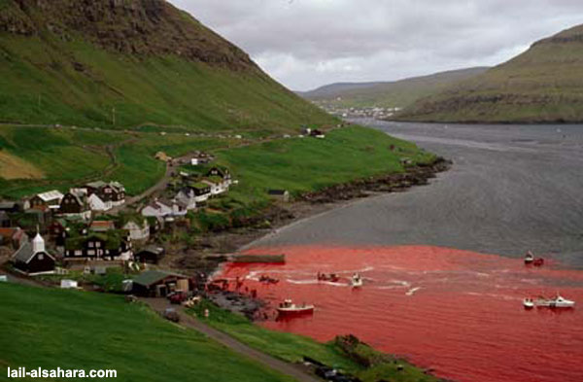

It's because of the cruelty that the human beings depict. They kill hundreds
of famous and intelligent Calderon dolphins.

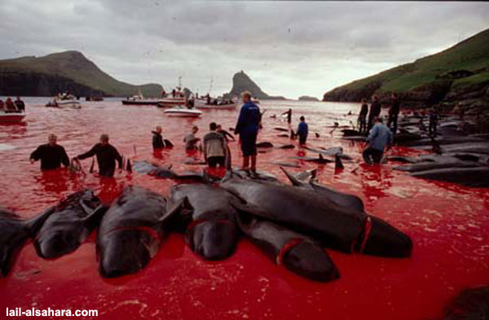

This happens every year in Feroe island in Denmark. In this slaughter the main participants are young teens.
WHY?
To show that they are adults and mature....

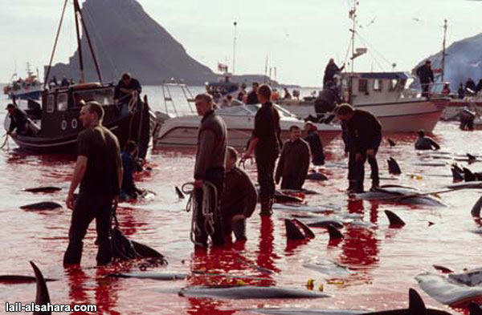

In this big celebration everyone is participating in one way or the other, killing or looking at the cruelty.

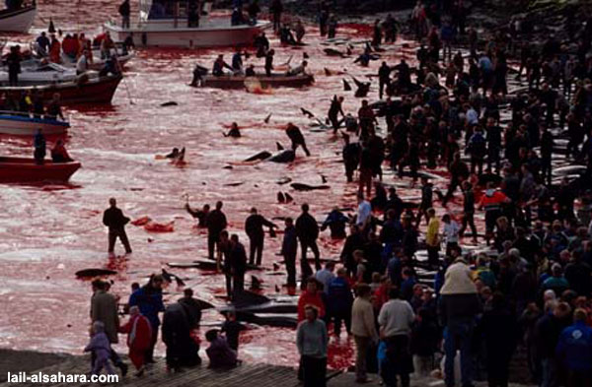

Like all the other species of dolphins, they too love to play and interact with human beings.
Is it necessary to mention that the dolphin calderon, is near extinction because what man has done.

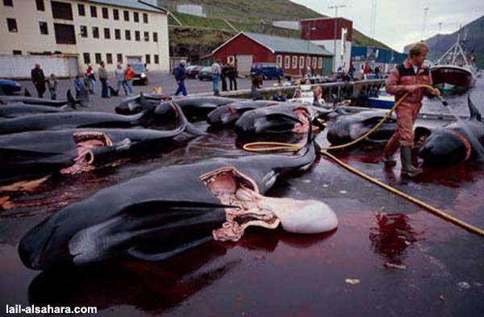

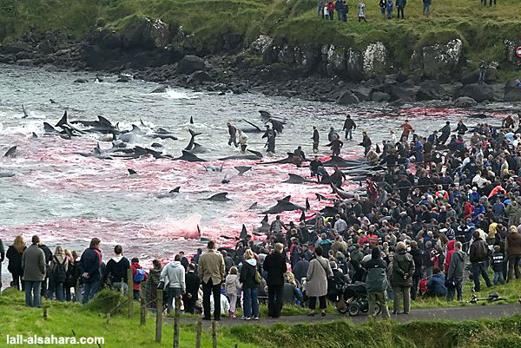

They don’t die instantly; they are cut 1, 2 or 3 times with thick hocks. And at that time the dolphins produce cry similar to that of a new born child.

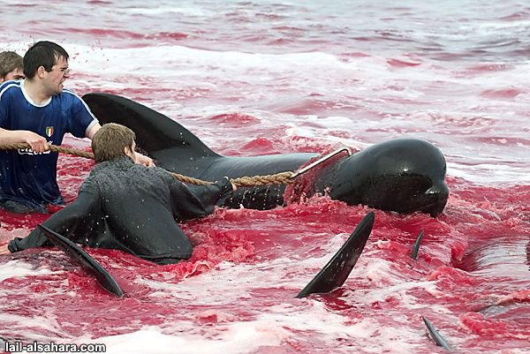

But it suffers and there’s no compassion till this sweet being slowly dies in its own blood.

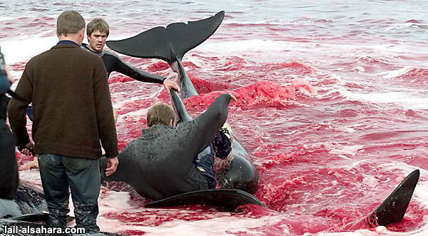

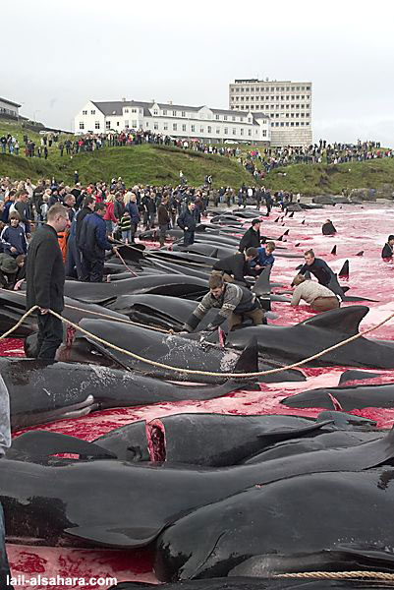

It’s enough!

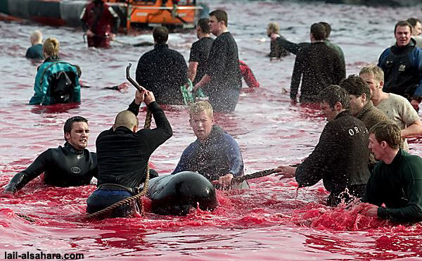

Take care of the world, it is your home!

