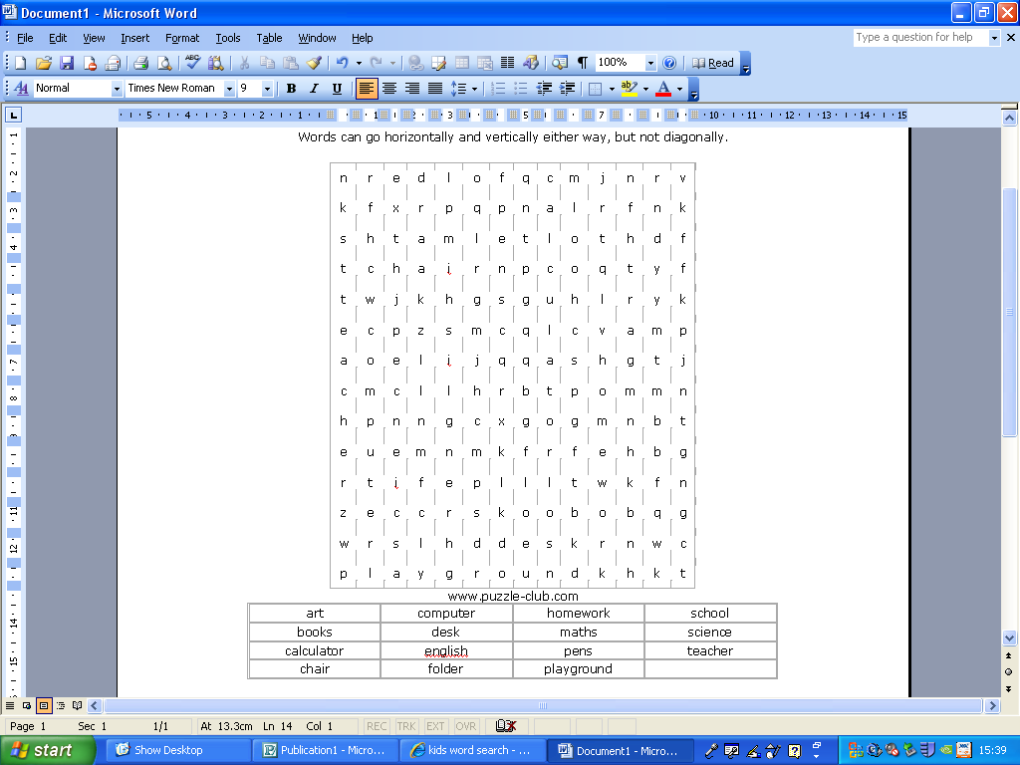

Redlands Community Primary School has raised £549.56 for the Haiti Earthquake near the Domican Republic.
Lots of you dressed up as your hero: Superman, Batman Etc.
You all brought in your money for the donation.
At the end of school we had a cake sale.
We added that altogether and we got a stupendously Massive total of: £549.56.
WELL DONE TO ALL OF YOU!
Year 6 have had the opportunity to make tops with graffiti, with Tom Cleaver. all of year.6 have lots of fun making them.

Also Year.2 had a chance to make cakes.
I bet they were nice YUM YUM

Good Websites
http://www.bbc.co.uk/schools/ks2bitesize

http://www.bbc.co.uk/cbbc/games/
Agame.com
http://www.woodlands-junior.kent.sch.uk/maths/countdown/index.htm

