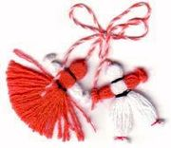
A legend about the martenitsa
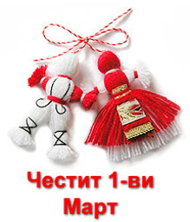
Khan Kubrat's five sons went hunting accompanied by their sister Huba. When they reached the Danube River they saw a silver stag. Charmed, the men did not dare shoot at it. The stag crossed over to the opposite bank of the river showing them a ford. A bird flew bringing them bad tidings. Their father, the founder of Old Great Bulgaria was on his deathbed. In his last hours Kubrat's last will was to tell his offspring—Bayan, Kotrag, Asparukh, Kuber and Altsek—not to sever the still tenuous link between the different Bulgarian tribes. His sons vowed to defend Bulgaria. Soon after their father’s death, the Khazars invaded the land. The Khazar's Khan Ashina conquered the capital Phanagoria. Huba, Kubrat's daughter, was captured by Ashina. Hoping to give her brothers a chance to freedom, Huba attempted suicide but was stopped by the guards. Her brothers kept their vows in different ways. Bayan stayed with his sister and recognized the supremacy of the Khazars. Kotrag went northwards, to the River Volga, while Asparukh, Kuber and Altsek went south to search for a new land without oppressors. The brothers who left secretly arranged with Huba and Bayan to send word by a golden thread tied to the leg of a dove if they were able to find a free land. One day a falcon sent by Asparukh flew into Huba's room and she and Bayan quickly made plans to escape. Just as they were looking for a place to cross the Danube River, Khazar pursuers spotted them and rushed toward them. Trying to find a ford, Huba let the falcon free. She tied a white thread to its leg and handed it to her brother. Just as the bird was about to take off, an enemy arrow pierced Bayan and his blood stained the white thread. While Huba and Bayan managed to reach the newly discovered land by Asparukh (present-day Bulgaria), they were both mortally wounded. Asparukh rushed to the side of his dying brother and sister but he could not save them. After their death he tore the pieces of white-and-red blood stained yarn and adorned his soldiers with them.
