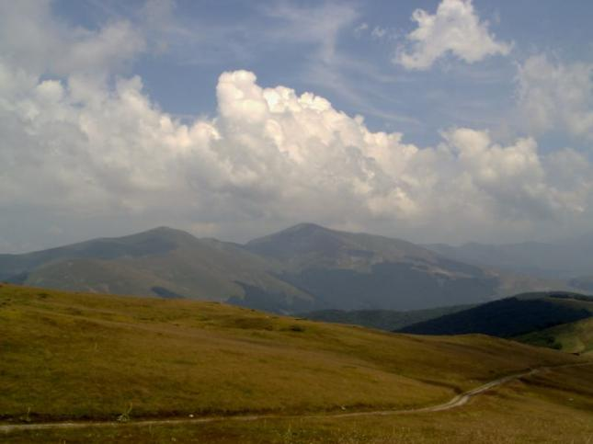

Todora’s dolls

The village of “Spanchevtsi’’ was on ordinary village like many others - with beautiful lassies and handsome young men, with working-bees and merry-makings. The young people gathered to have fun and tell stories. But among all of them there was a lassie named Todora who was distinguished for her beauty, she charmed all young men with a single look. All young men liked Todora and wanted her to be their future wife. But she wanted a man who was brave-hearted and she told them that her future husband would be the man who would take her distaff to the highest peak. But nobody dared to go out at night. Then Todora to show courage and fearlessness said loudly: ‘I will go there and put my distaff on the peak’. She left the village at night and reached the peak. It was wet and quiet there. Only the peak was plunged in moonlight. Todora stuck her distaff with her last strength left without seeing that the distaff had caught her long sleeveless dress. She tried to stand up but she couldn’t do it. She was scared to death; her heart started to beat intensively and blew up. In the morning her friends found her dead. To honor Todora’s memory people named the peaks Todora’s dolls.

