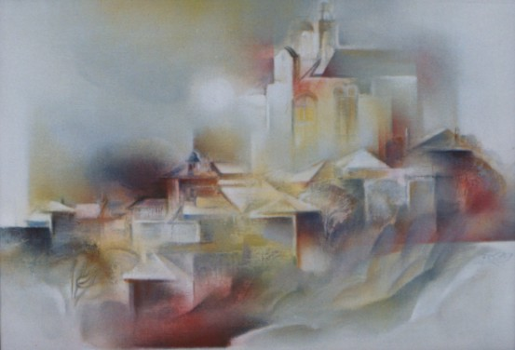

Legends of my people

The history of the Balkan peoples represents an organic part of the human civilization’s history. Our millennial presence on this land at crossroads has many dimensions. The most fabulous one are the myths and legends, carried throughout the time. They intertwine pain and beliefs, suffering and dreams, imagination and passions. Different and often amazingly close, they together carry the spirit of the people from this part of Europe.
A lot of men - strong heroes with brave hearts – were born on our lands. They were fearless Bulgarians that fought the strongest enemies, the dragons, and the worst enemies...
A lot of maidens were born on our lands - clean as morning dew, beautiful as the sun, the moon and the stars, and with dresses reminding a bunch of spring flowers...
A lot of builders were born in Bulgaria - and their wonderful bridges, fountains and buildings are still here.
Many great story tellers and singers were born on our lands; their voices reached the sky as well as their hearts. Their fame and their legends stayed with us through the centuries. They tell our people the stories of the strong heroes, the maidens as beautiful as the sun, the artistic builders whose creations stand still here...

