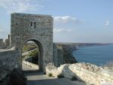
Kaliakra

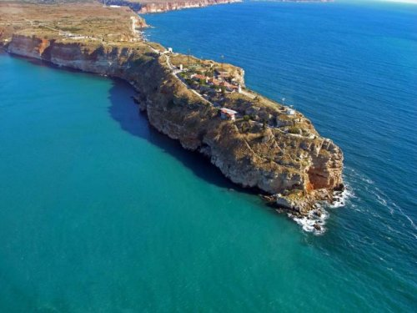
Kaliakra is a long and narrow headland in the Southern Dobrudzha region of the northern Bulgarian Black Sea Coast. Kaliakra is a nature reserve, where dolphins, cormorants and pinnipeds can be observed. It also features the remnants of the fortified walls, water-main, baths and residence of Despot Dobrotitsa in the short-lived Principality of Karvuna's medieval capital.
The name "Kaliakra" is of Byzantine Greek origin and is traditionally translated as "Beautiful Headland". Probably the most popular legend about the place is the one about 40 Bulgarian girls, who preferred to tie their hair together and jump into the Black Sea instead of the prospect to be captured by the Ottomans. An obelisk dedicated to this legend is placed at the entrance to the cape, called The Gate of the 40 Maidens. Another legend tells the story of St Nicholas, the patron of seamen, who was running away from the Ottomans and God was making the earth under him longer and longer, so he could escape, and the cape was formed this way. The saint was eventually captured and a chapel was built in 1993, symbolizing his grave. A dervish monastery is also said to have existed on the same place during Ottoman rule, which is thought to have preserved the relics of Muslim Bektashi saint Sarı Saltık. A third legend is about Lysimachus, a successor of Alexander the Great, who seized the royal treasure and escaped to Kaliakra, dying in a major storm along with his whole fleet.

